This month is such a special one
It's birthday-time for you
We'd really like to celebrate
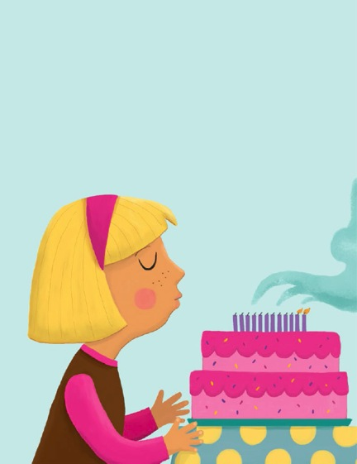
Your happy day with you
Zip-a-dee-ay and heigh-dee-ho,
Here's something we can do
We'll sing a song that we all know 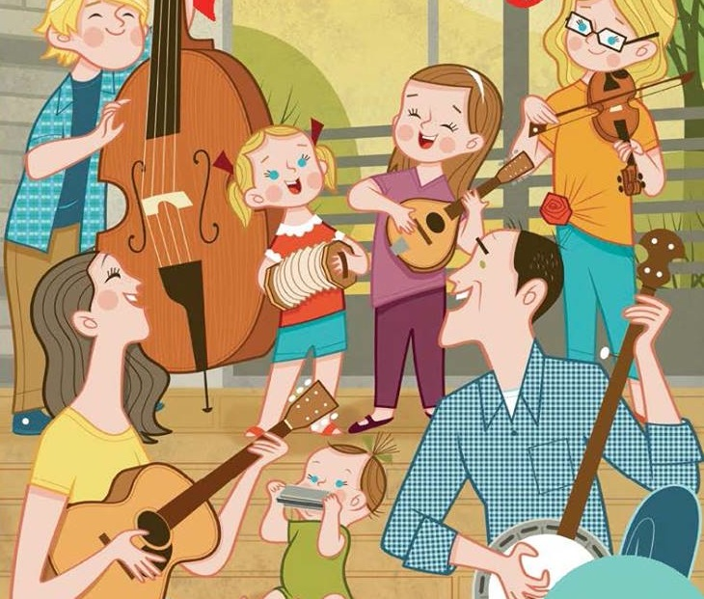Happy Birthday to you!

