I came to earth with power to choose
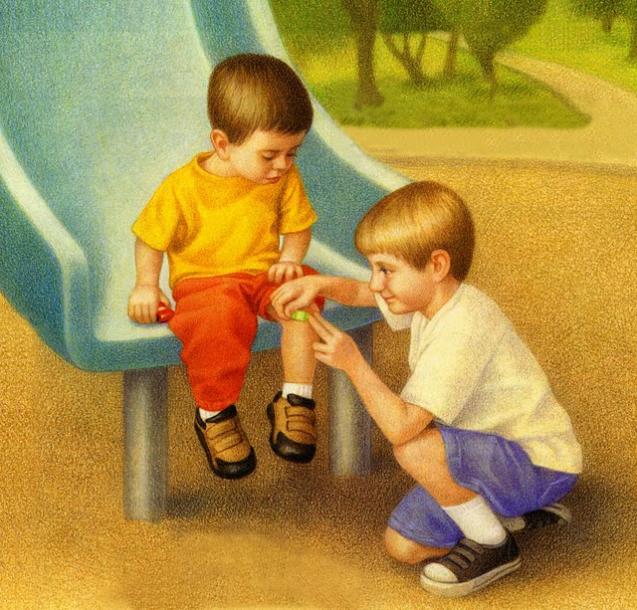
Good choices bless me and my family too
As a child of God, I receive special light
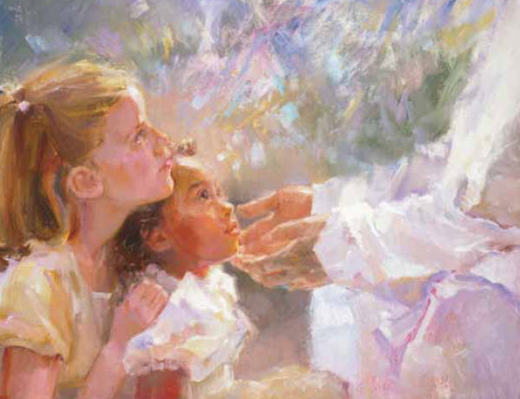
The Holy Ghost helps me to know what is right
I feel so safe and happy because
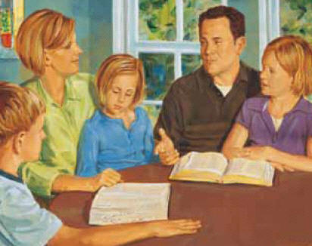
Such feelings of peace come from family love

In my own home I’ll happily serve
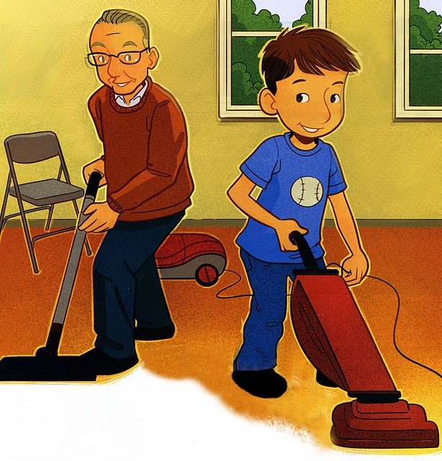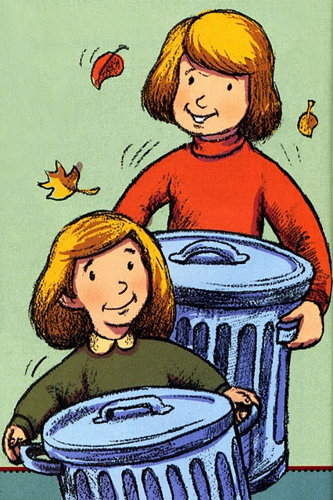
I’ll strengthen my family by my good works

