Bible stories teach us
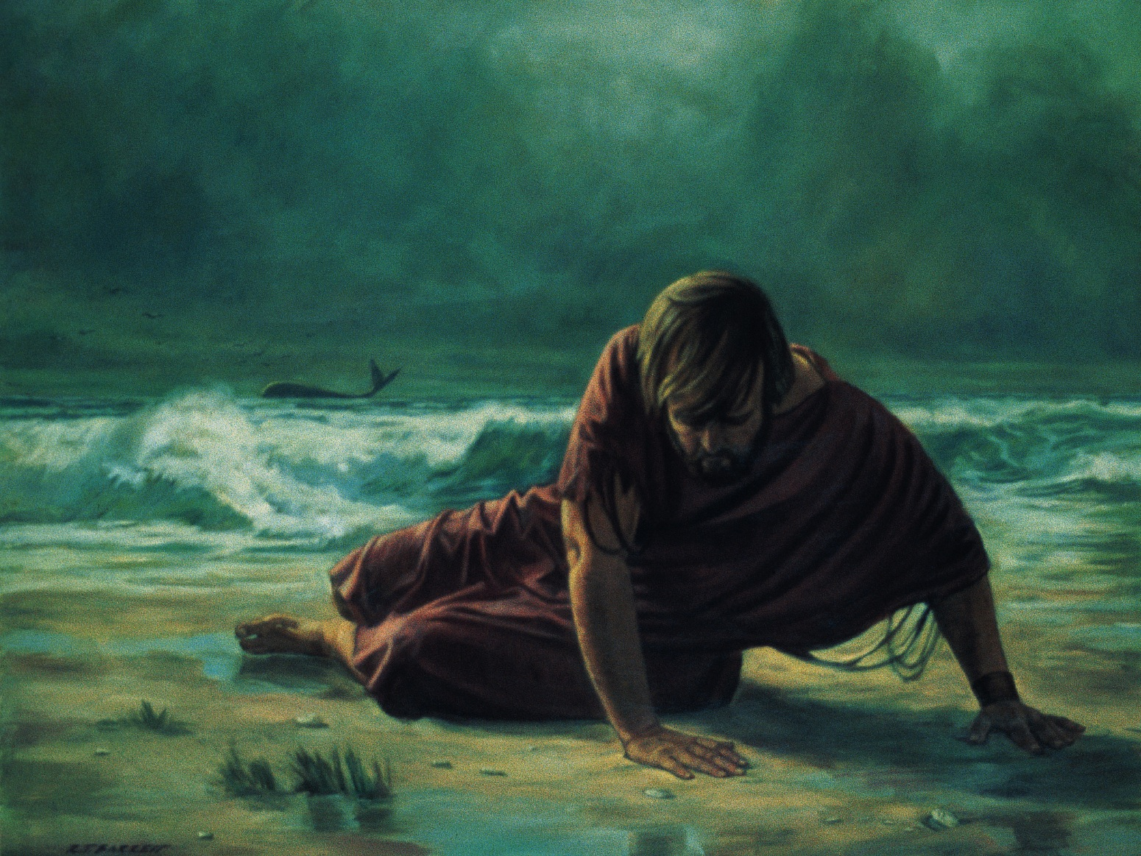
How to live like Jesus
Book of Mormon stories too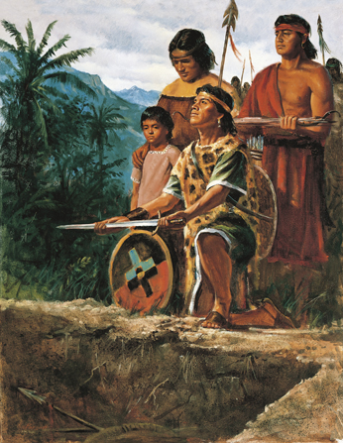
Tell what He would have us do
Hand in hand together
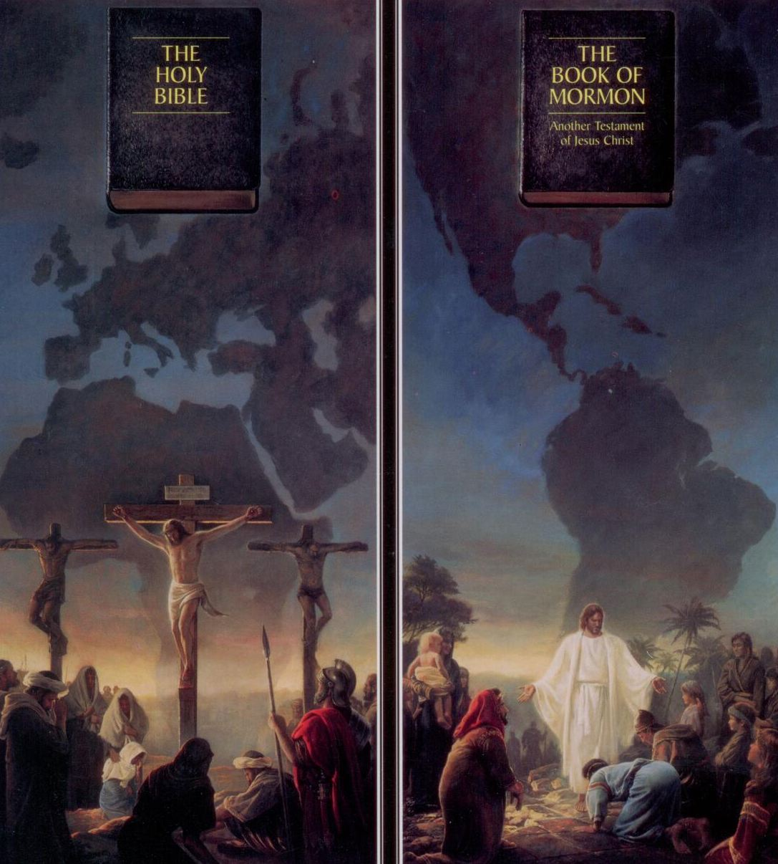
The Bible and the Book of Mormon
Stand forever to tell of Jesus Christ
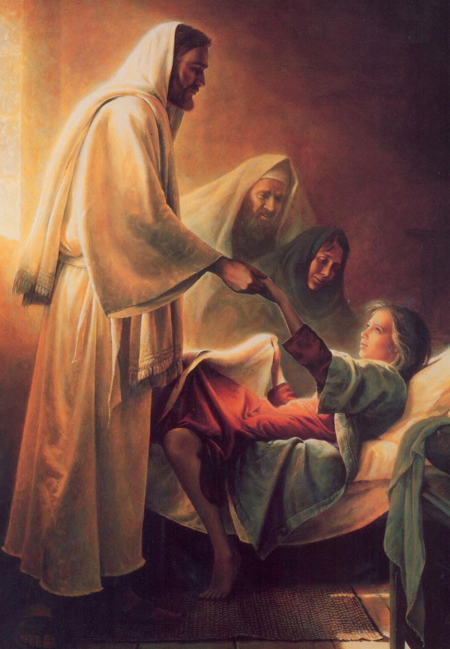
Bible prophets tell us
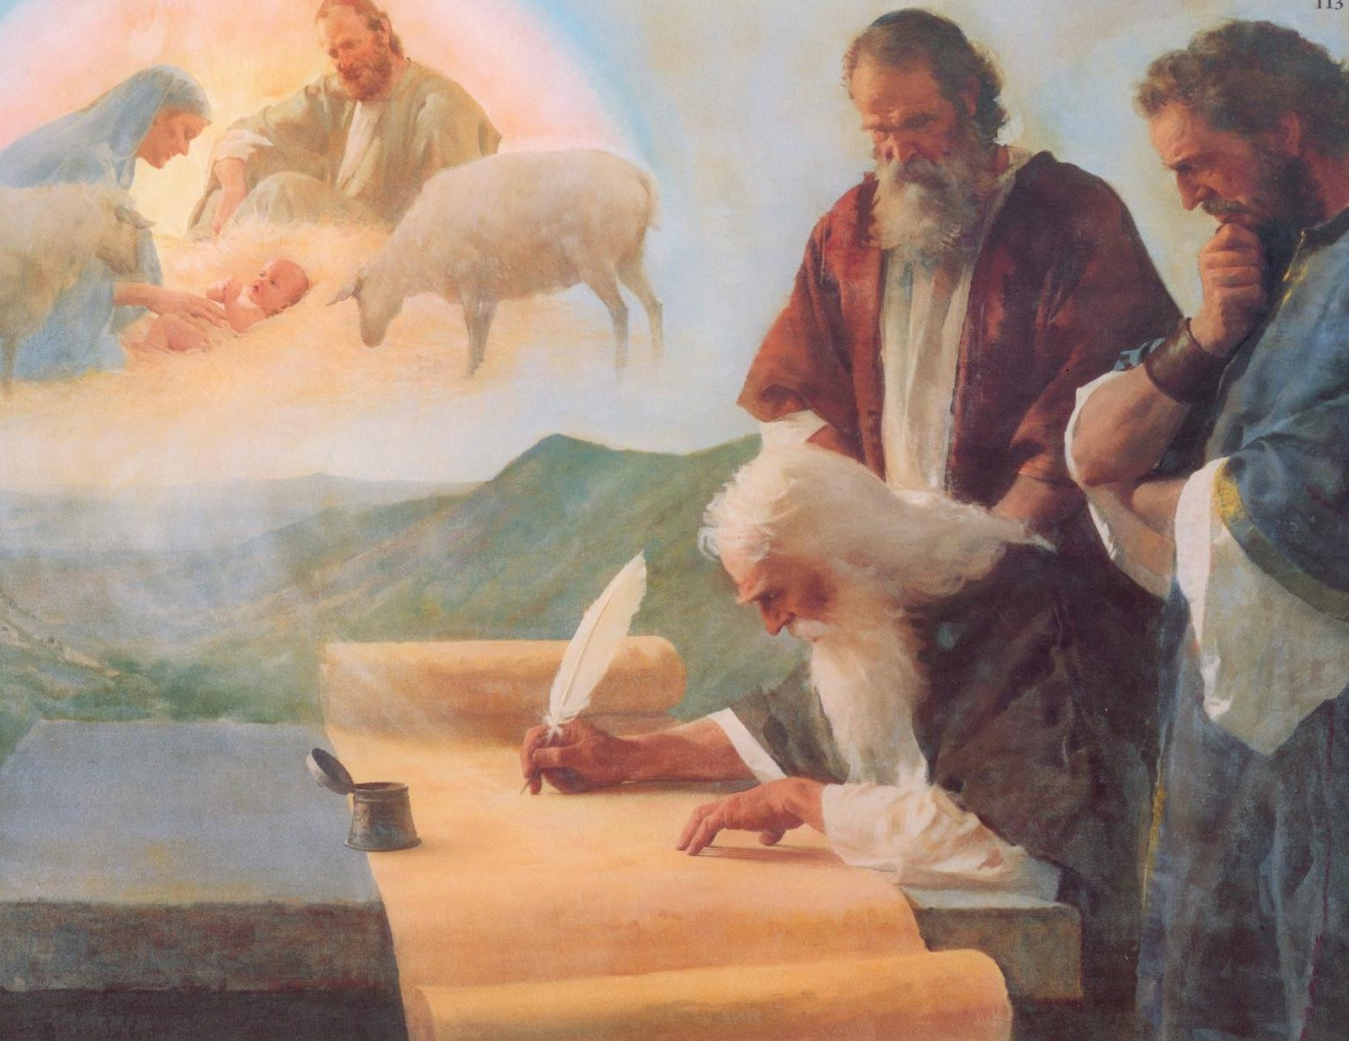
Things to bless and help us
Book of Mormon prophets too
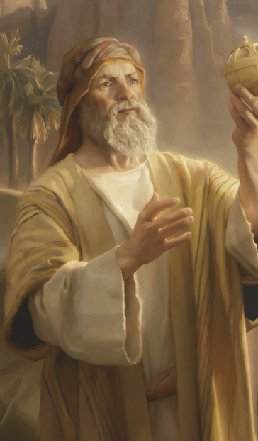
Testify of all that’s true
Hand in hand together

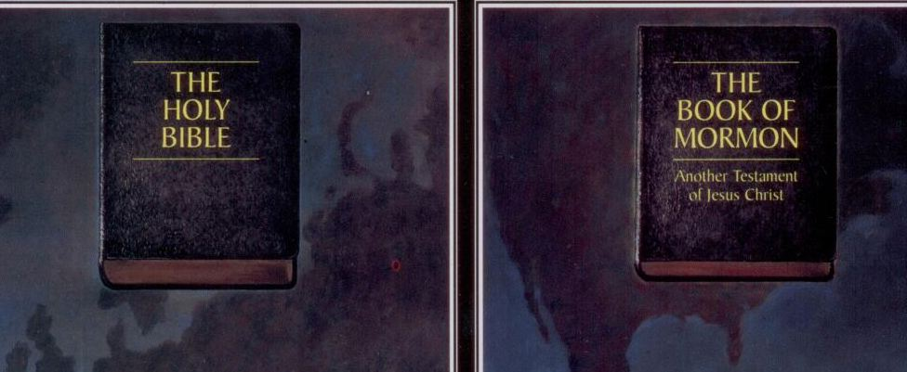

The Bible and the Book of Mormon
Stand forever to tell of Jesus Christ
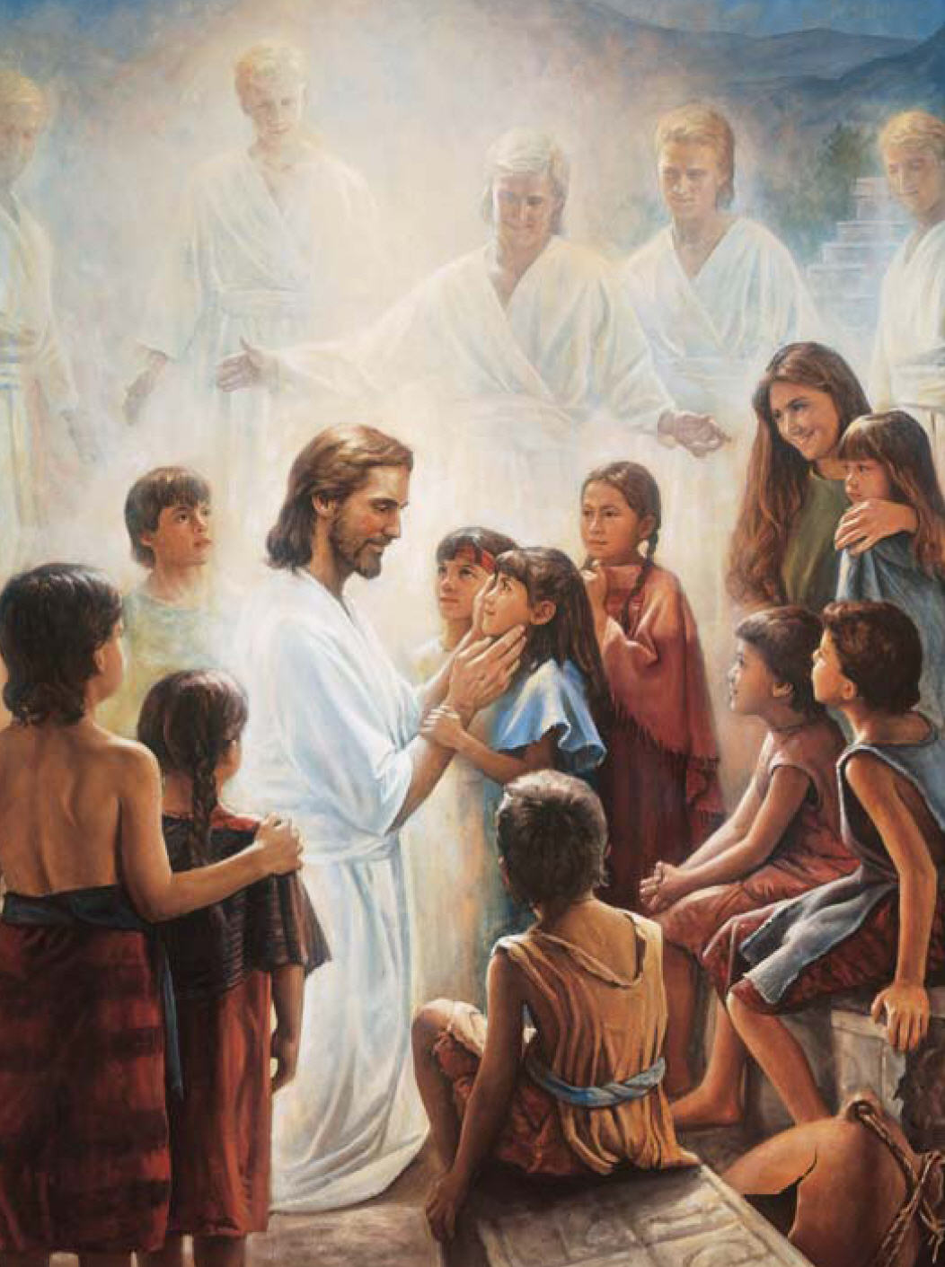
Hand in hand together
The Bible and the Book of Mormon
Stand forever to tell of Jesus Christ
