When Jesus Christ was on the earth
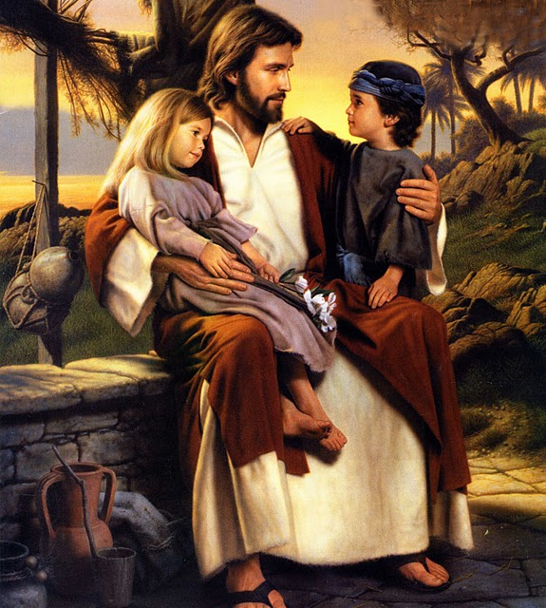
So many years ago
He taught our Heav’nly Father’s plan
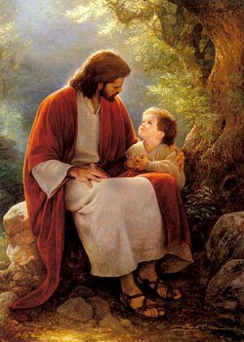
For children here below
Through parables with simple words
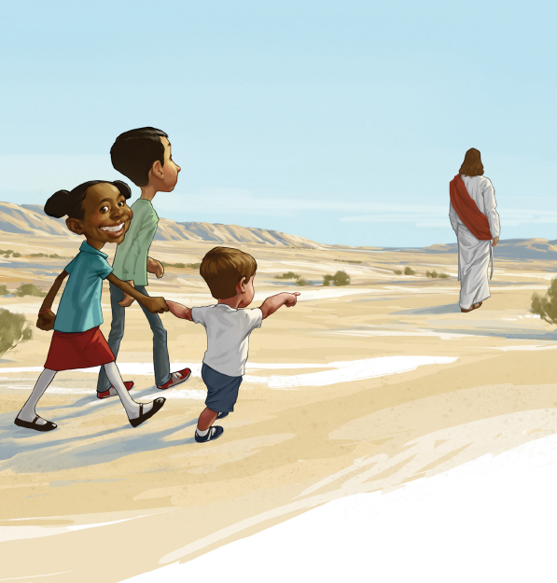
He said, “Come, follow me”
That we might now have joy on earth
And live eternally
That Easter morn disciples ran
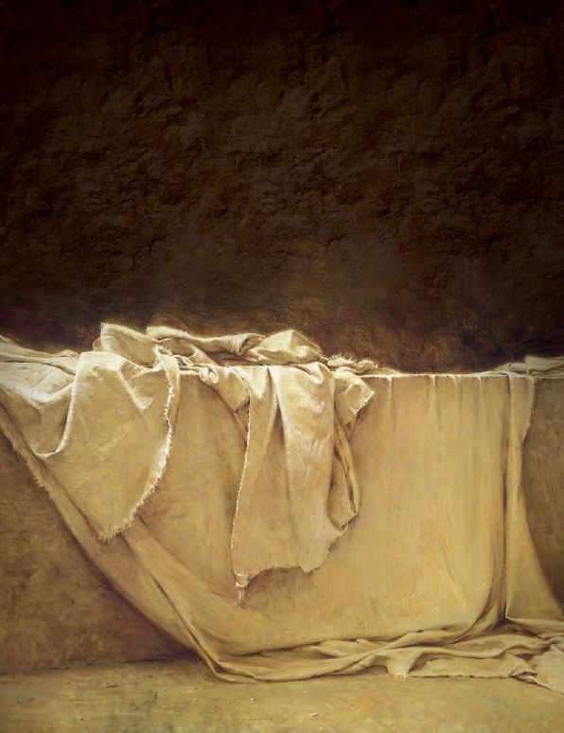
To see where Jesus lay
And there they saw a miracle
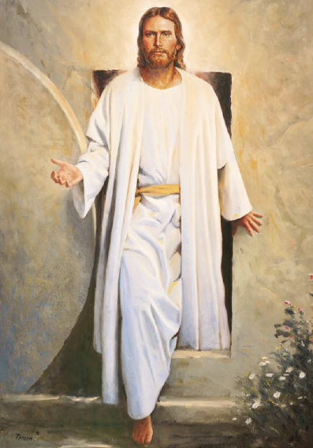
The stone was rolled away
He came for us
He died for us
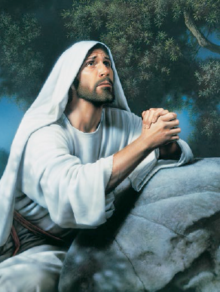
All to fulfill our Father’s plan
On Calvary, Gethsemane
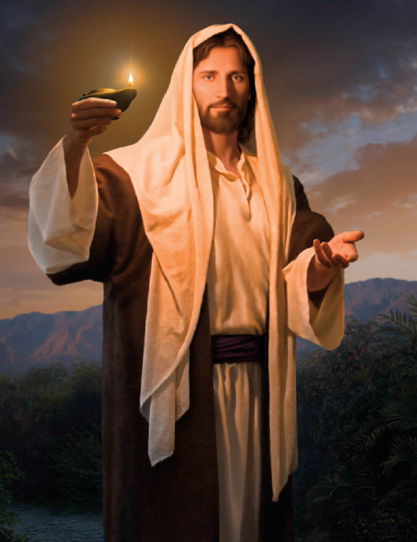
He sacrificed that we might live again

