I want to be like Noah
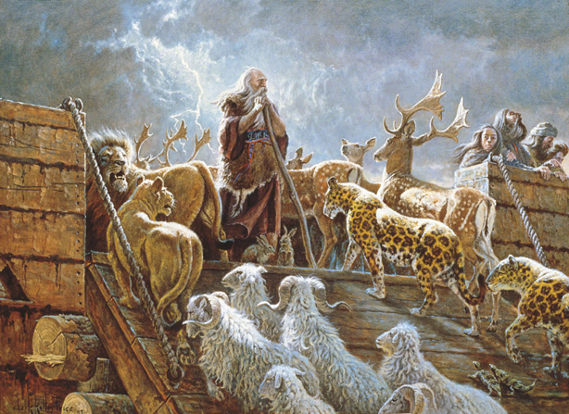
Obedient to the Lord
Courageous like Queen Esther
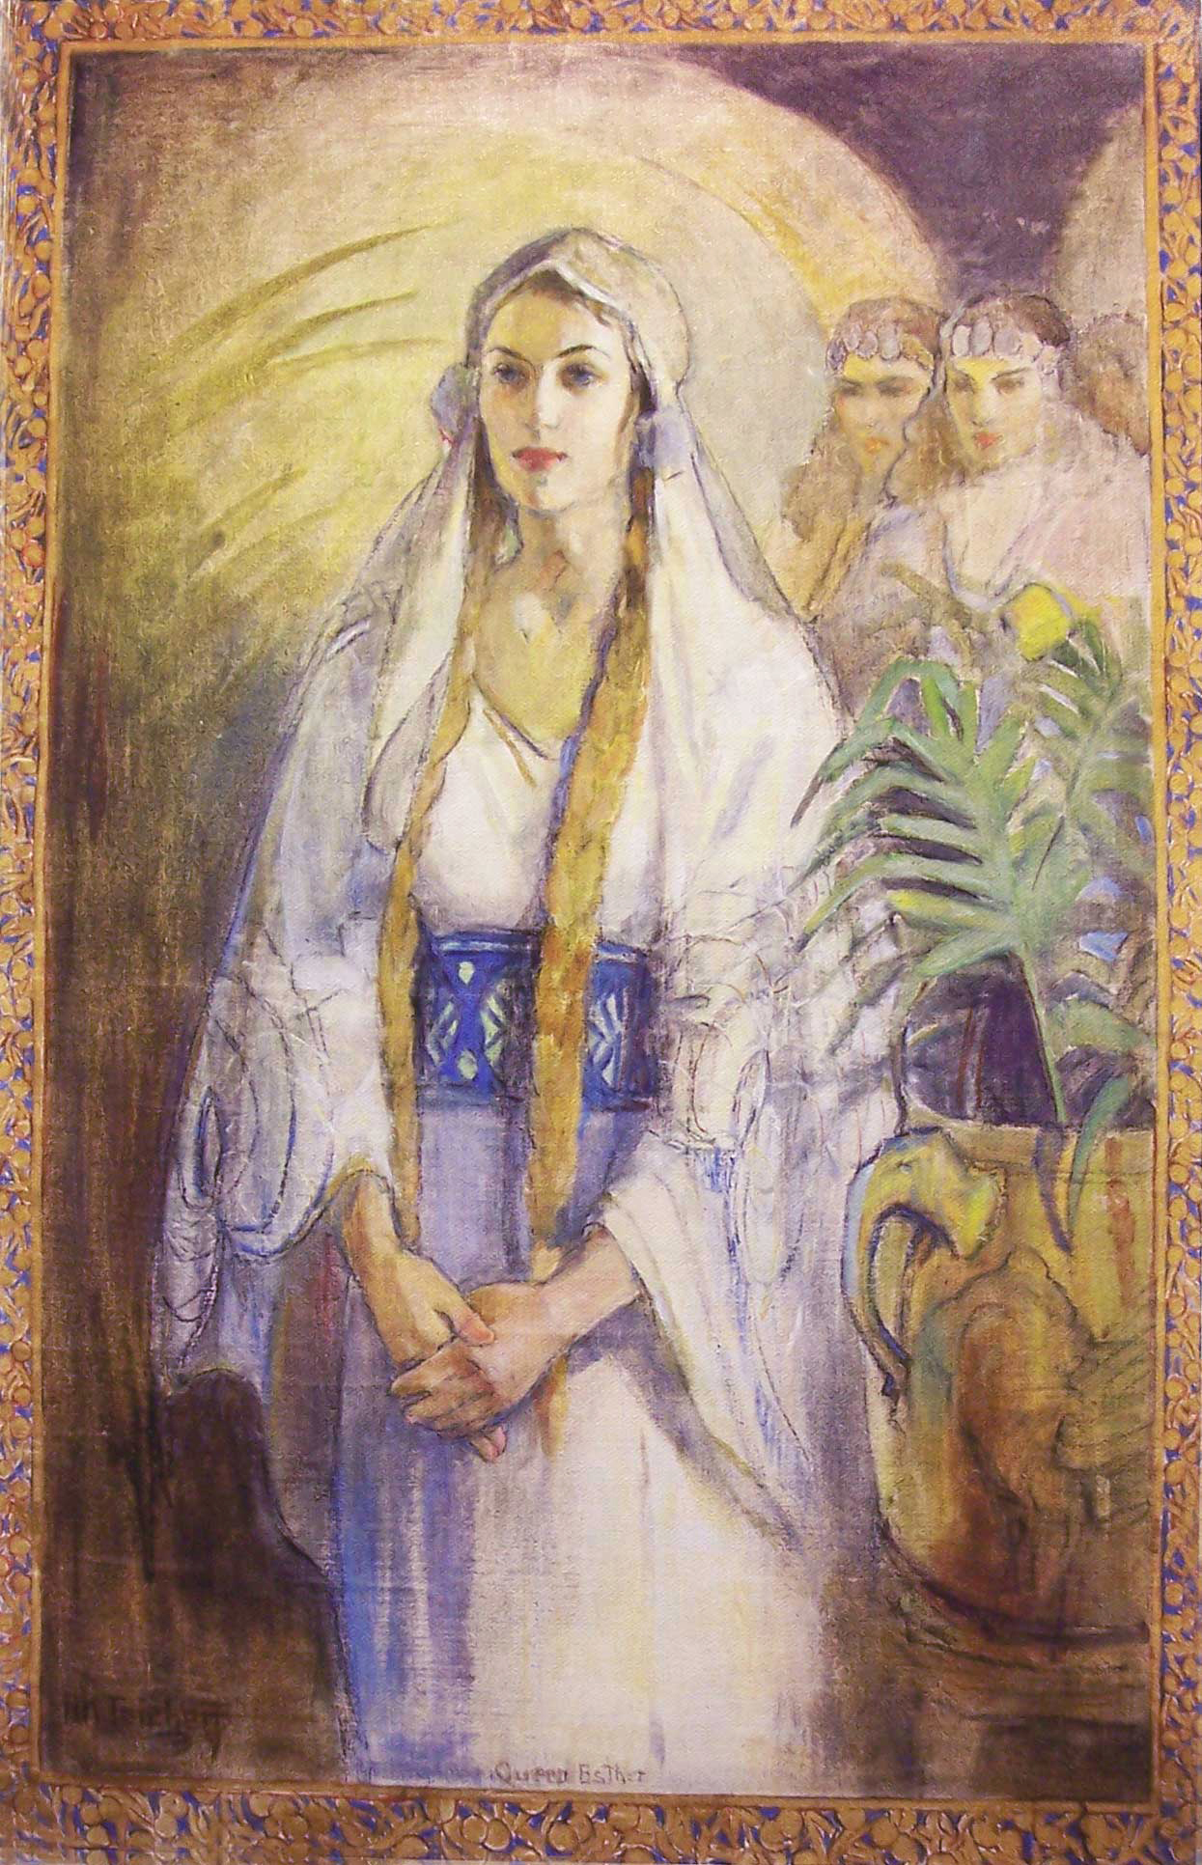
And Ammon with his sword
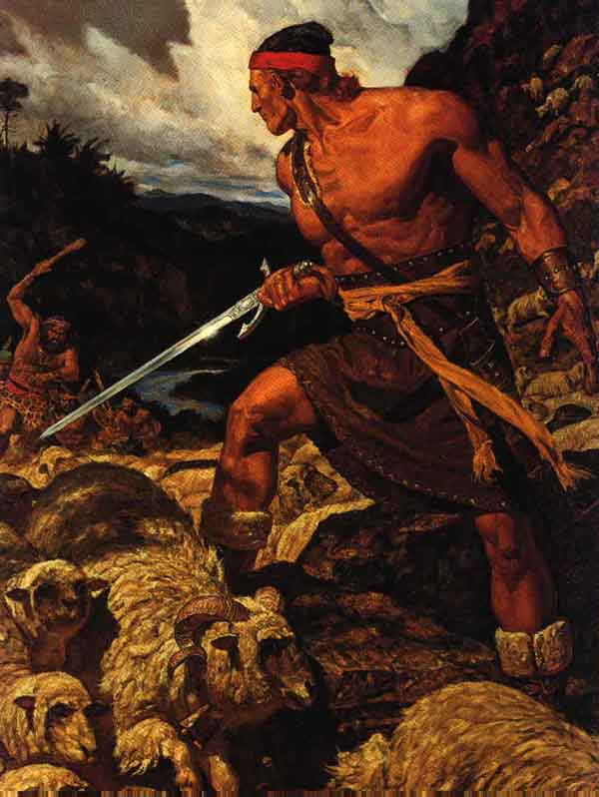
Like Ruth I would be faithful
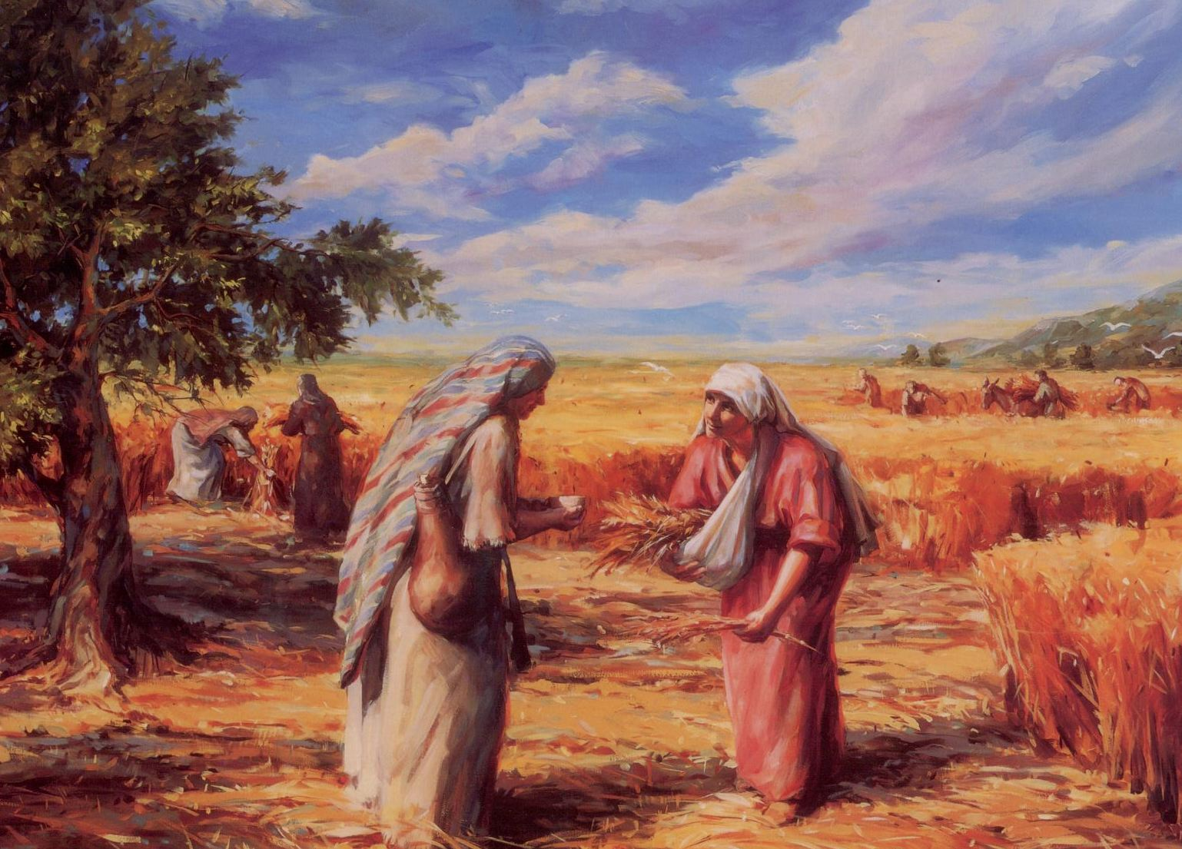

Like Moses I’d be true
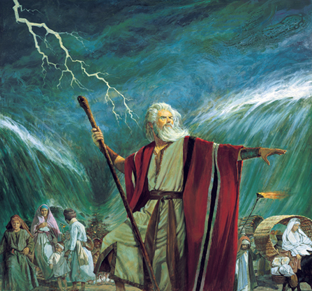
Examples in the scriptures
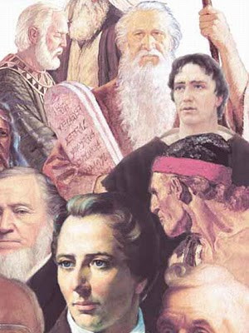
Can teach me what to do
I want to be like Daniel
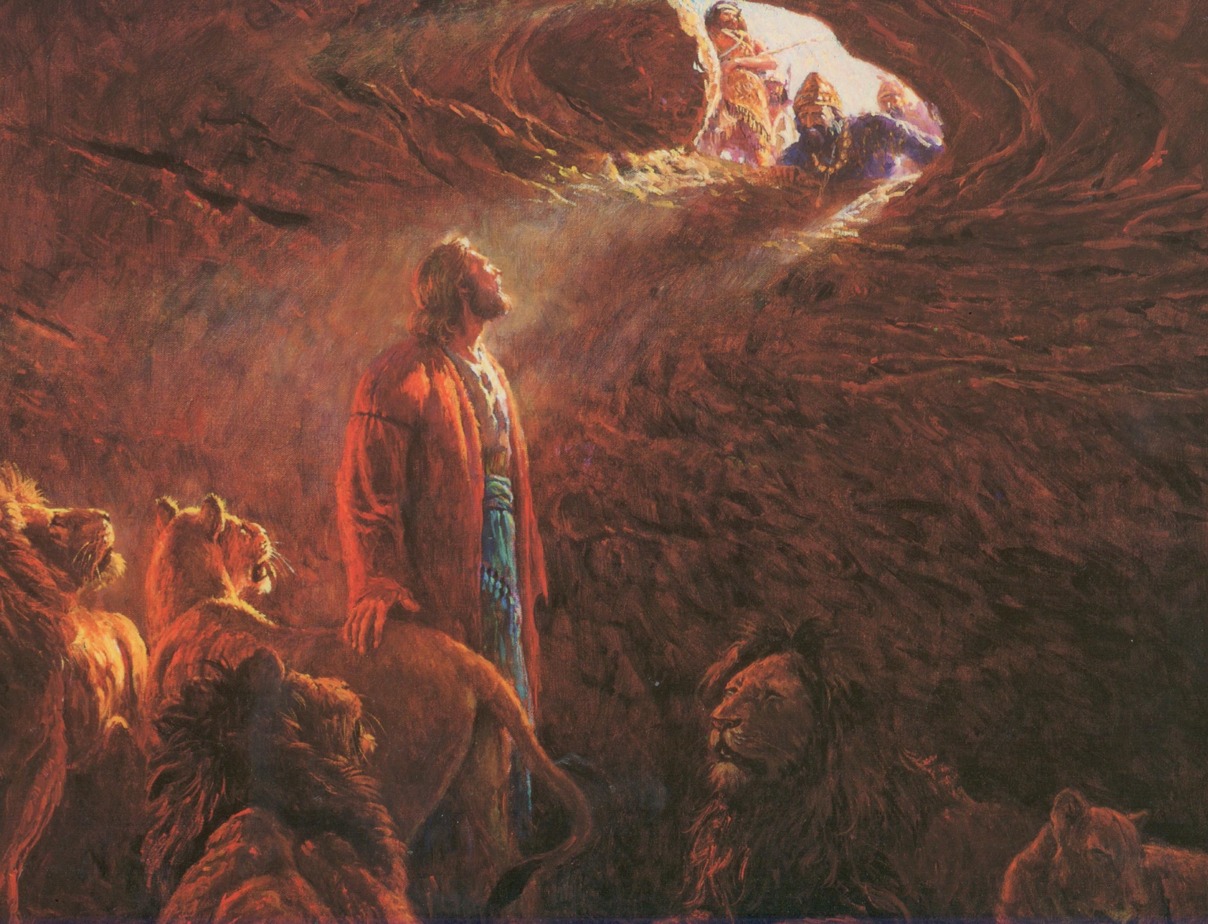
And stand up for the right
Like Joseph Smith seek wisdom
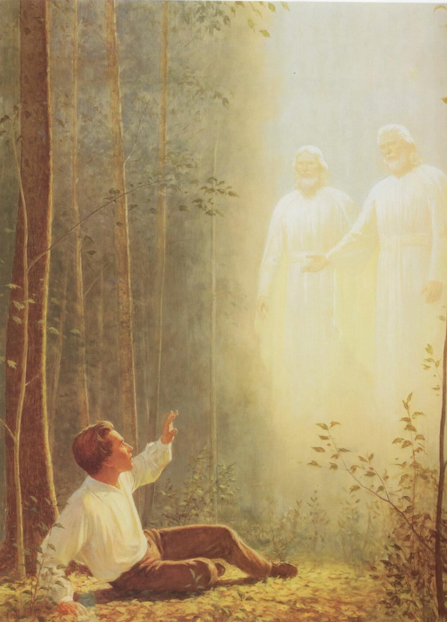
In prayer for heaven’s light
Sariah’s strength on journeys
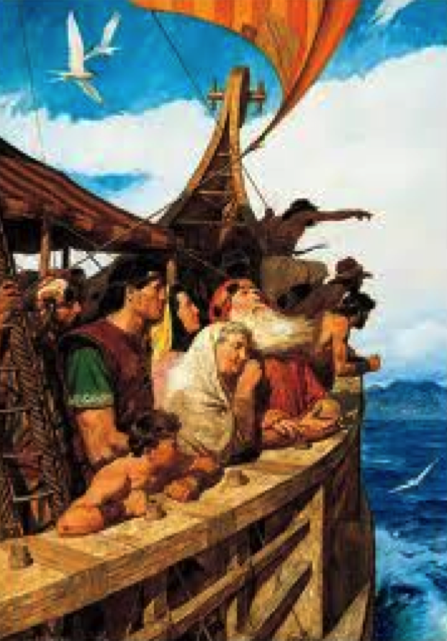
And Alma’s change of heart
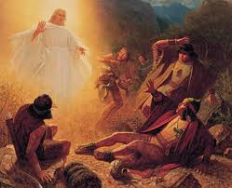

Inspire me to choose wisely
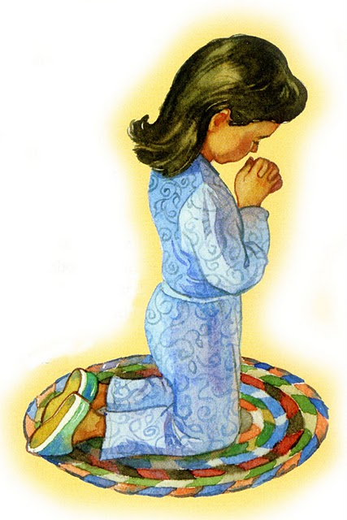
Repent and do my part
I want to be like Mary
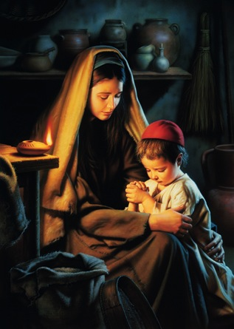
Rejoicing in the truth
Like Samuel and Moroni
Who listened in their youth
Examples in the scriptures
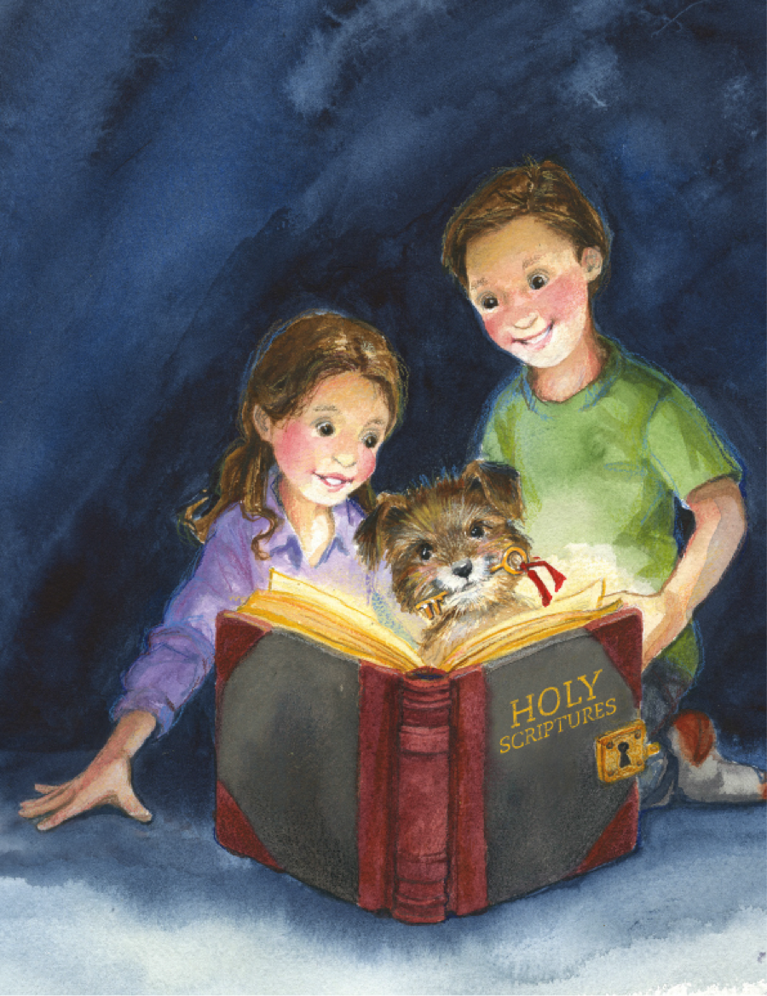
Can help me to become
Obedient, brave, and holy
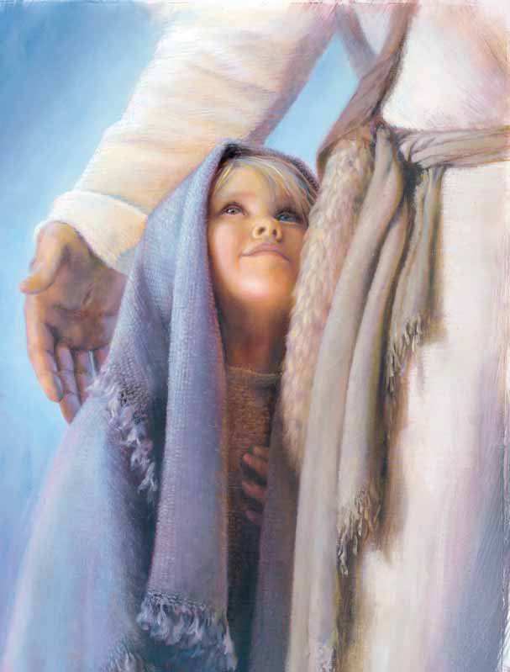
More like God’s perfect Son

