O Lord my God
When I in awesome wonder
Consider all the worlds
Thy Hands have made
I see the stars
I hear the rolling thunder
Thy power throughout
The universe displayed
Then sings my soul

My Savior God, to Thee,
How great Thou art
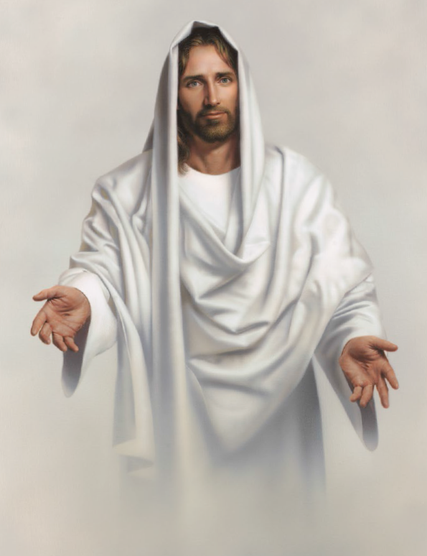
How great Thou art
Then sings my soul
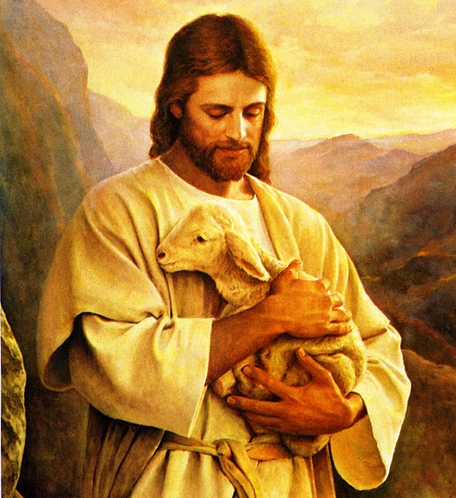
My Savior God, to Thee
How great Thou art
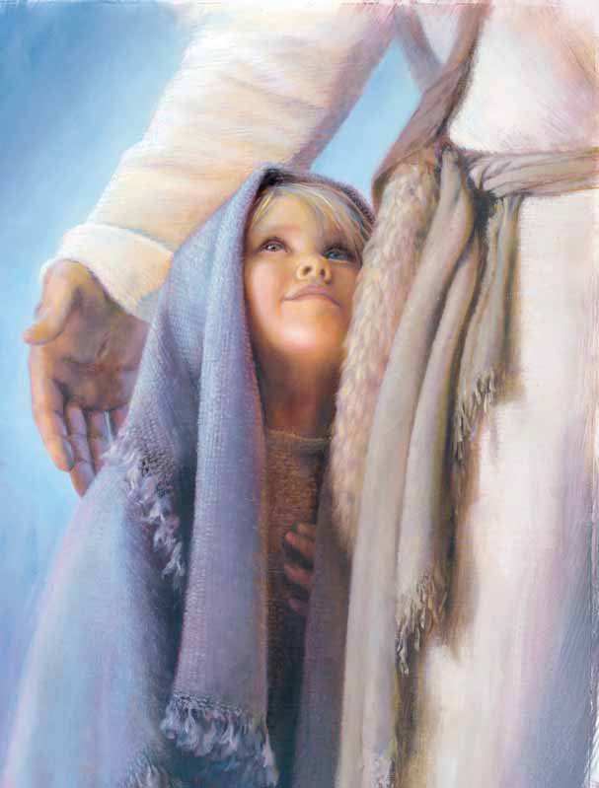
How great Thou art!
When through the woods
And forest glades I wander
And hear the birds
Sing sweetly in the trees
When I look down,
From lofty mountain grandeur
And see the brook,
And feel the gentle breeze
Then sings my soul

My Savior God, to Thee
How great Thou art
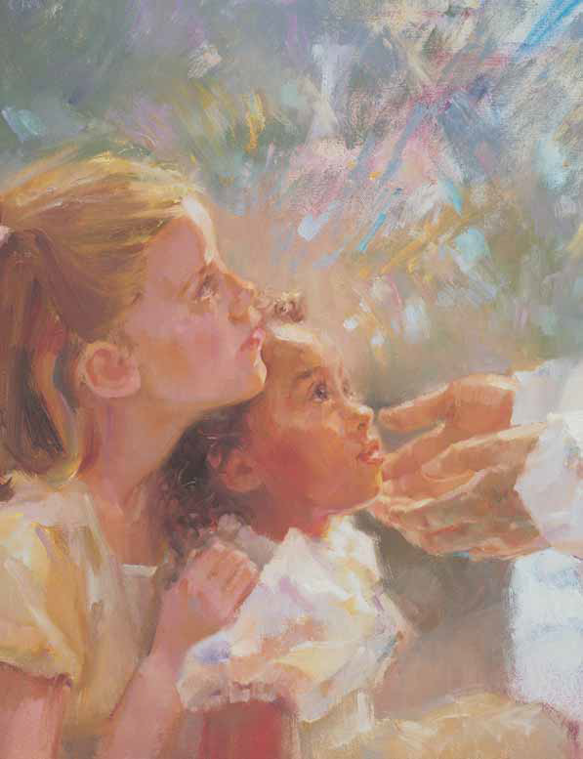
How great Thou art
Then sings my soul
My Savior God, to Thee
How great Thou art
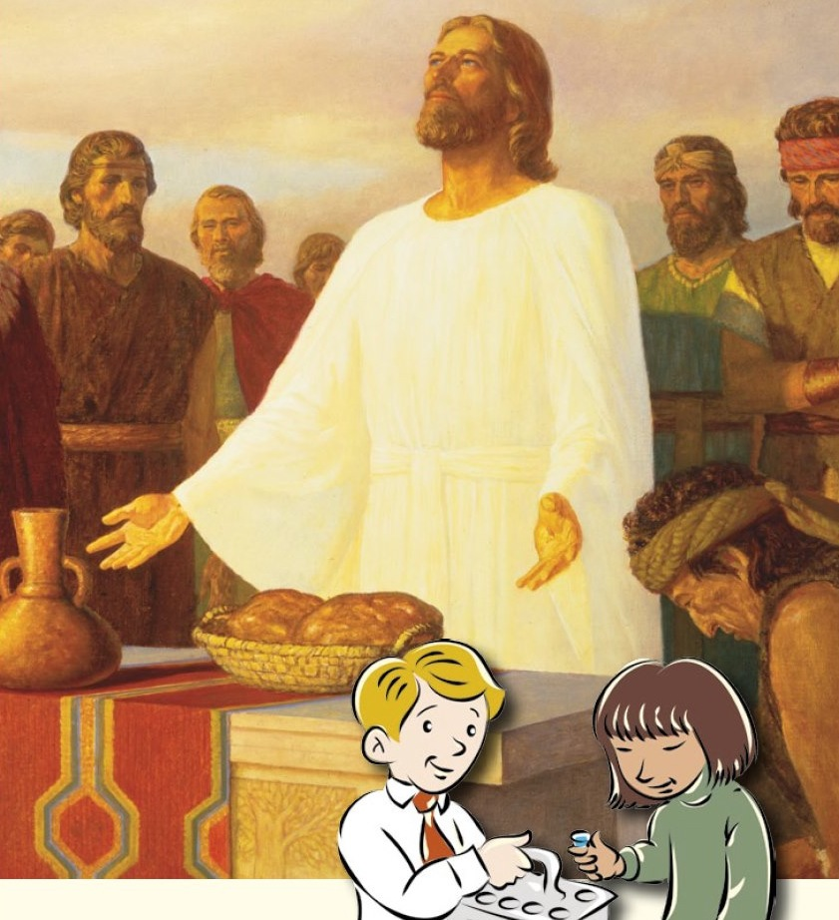
How great Thou art!
And when I think that God
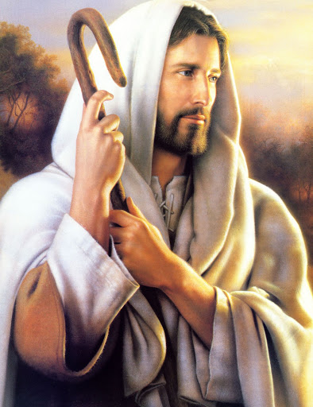
His Son not sparing
Sent Him to die
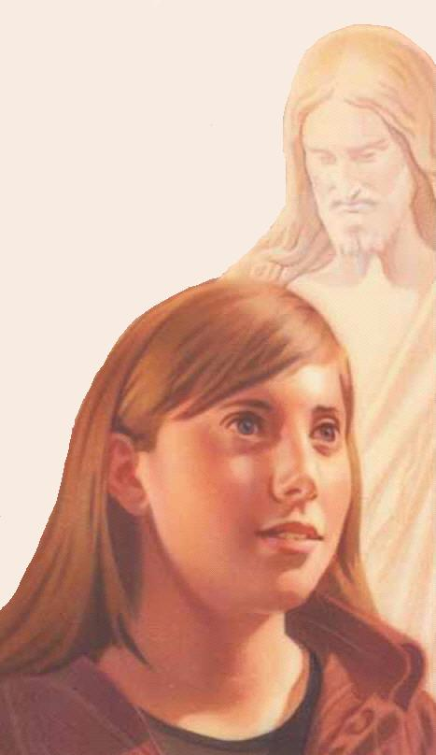
I scarce can take it in
That on the Cross
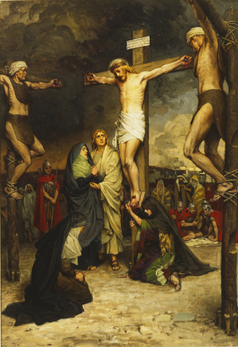
My burden gladly bearing
He bled and died
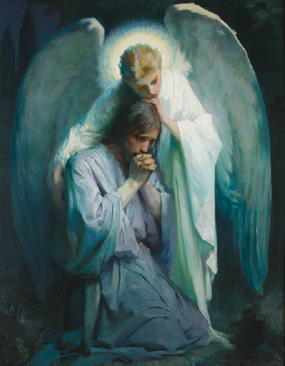
To take away my sin
Then sings my soul
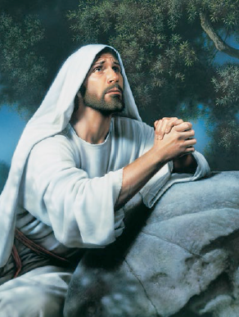
My Savior God to Thee
How great Thou art,
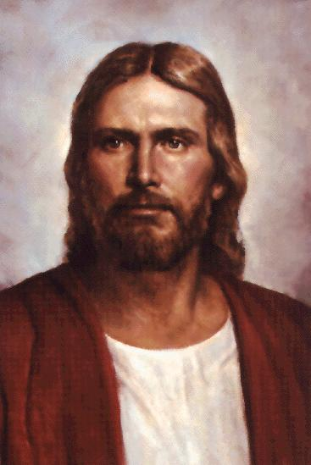
How great Thou art
Then sings my soul
My Savior God, to Thee
How great Thou art,
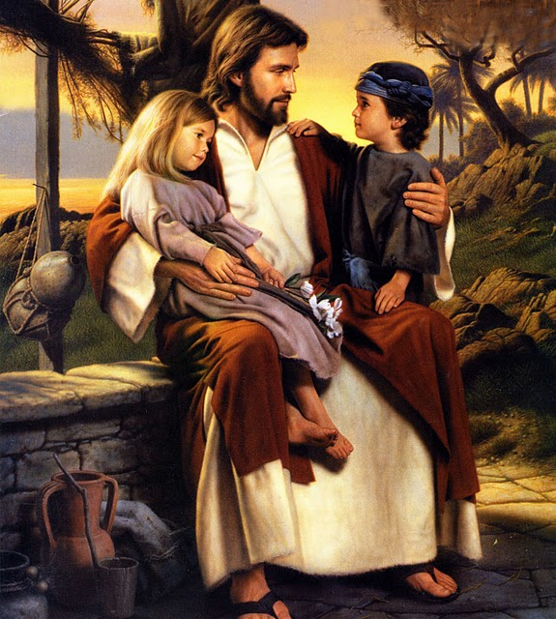
How great Thou art!
When Christ shall come
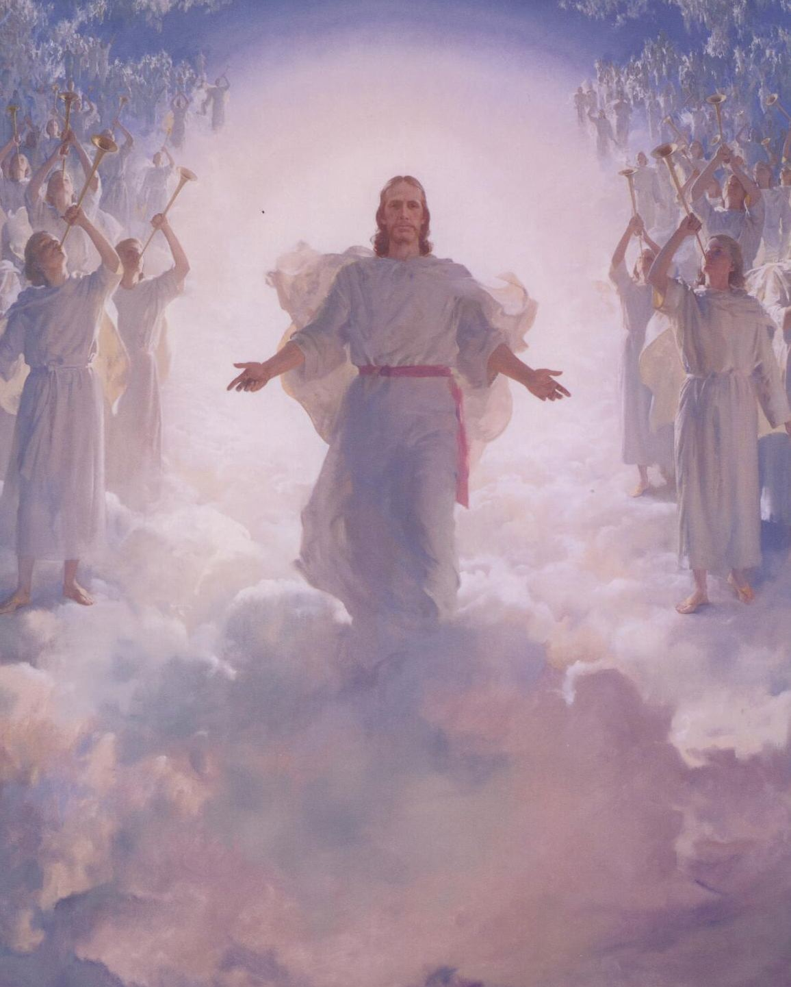
With shout of acclamation
And take me home
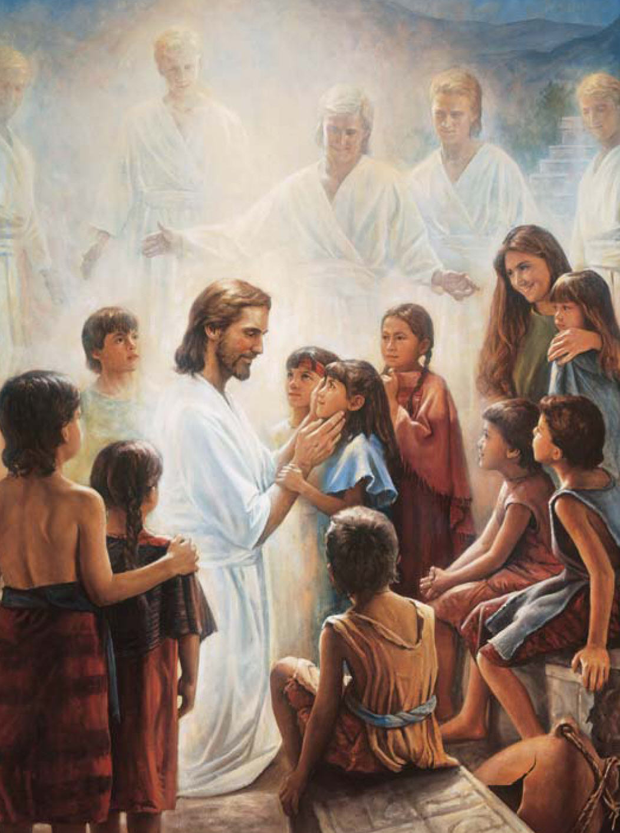
What joy shall fill my heart
Then I shall bow
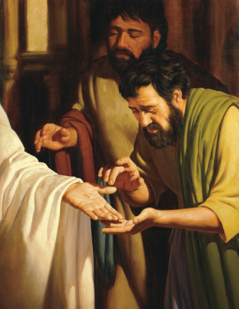
In humble adoration
And there proclaim
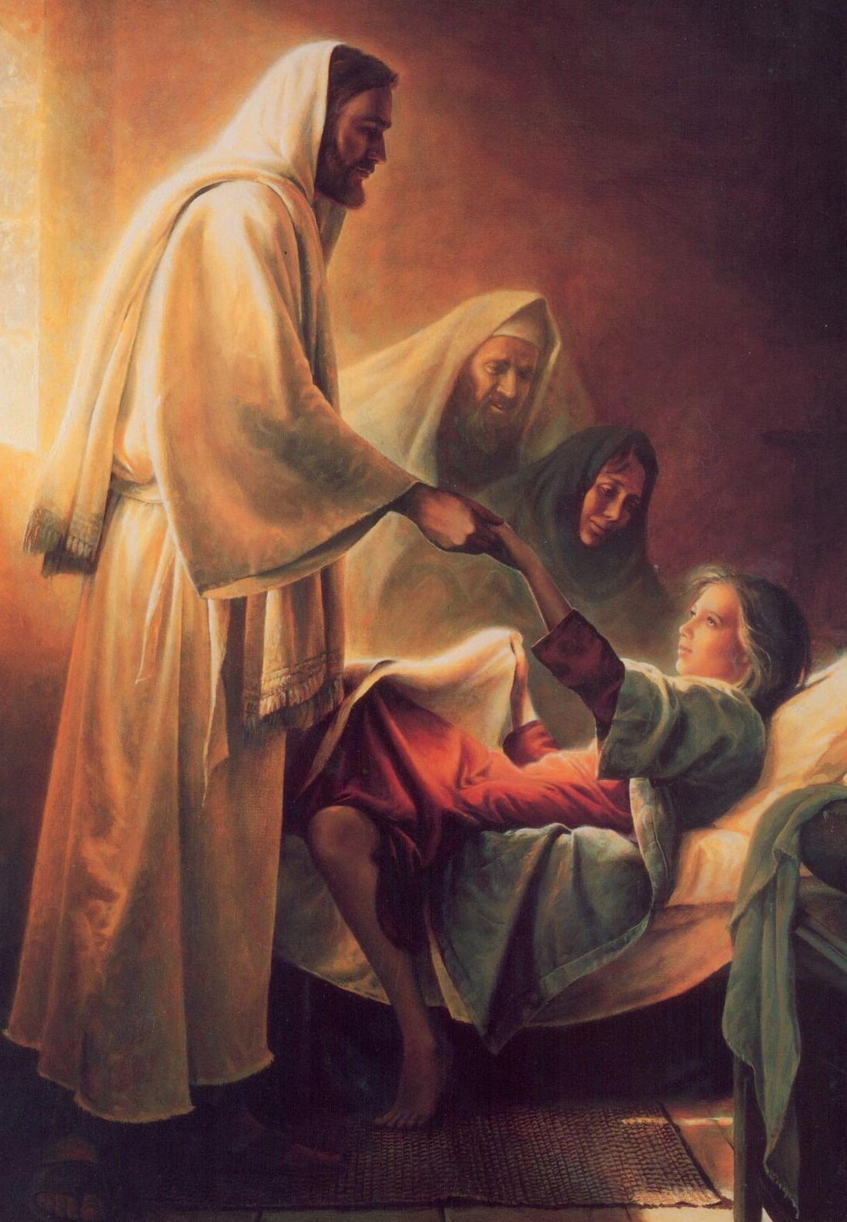
My God, how great Thou art!
Then sings my soul
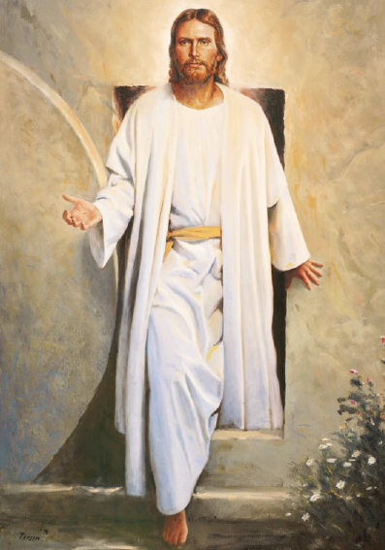
My Savior God to Thee
How great Thou art
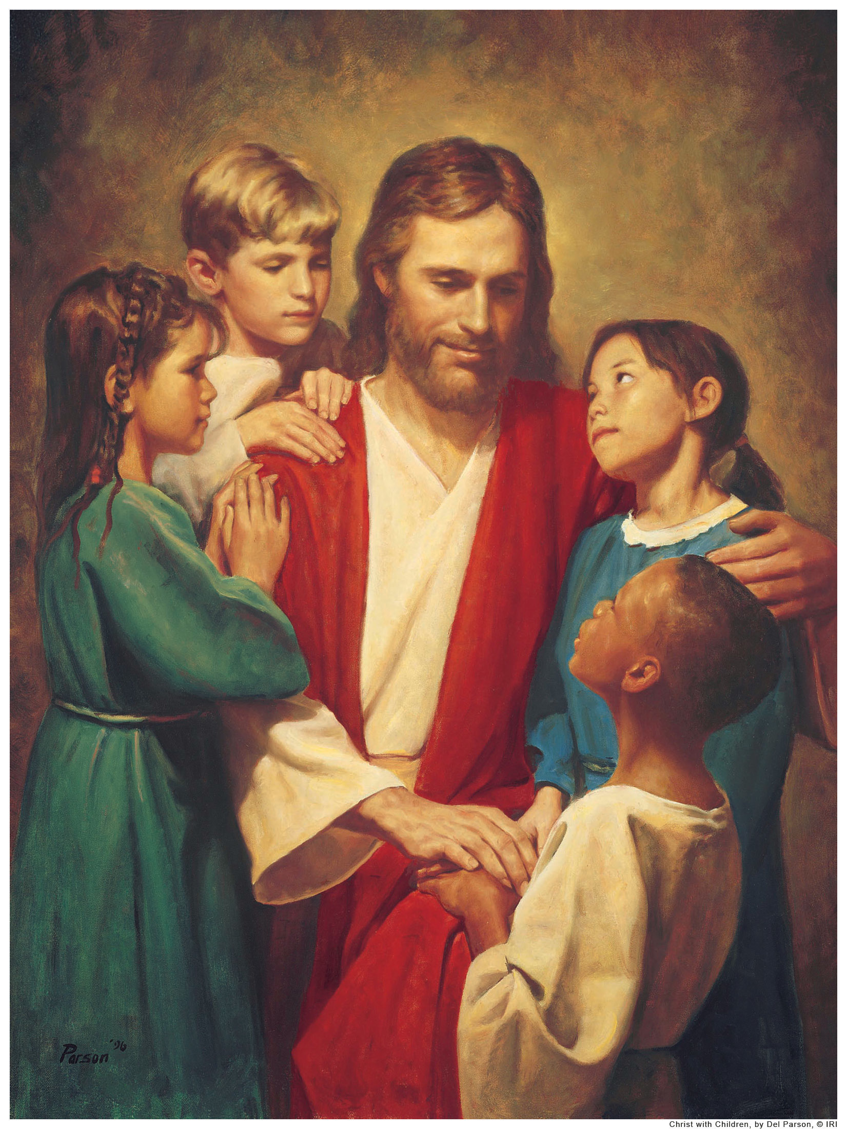
How great Thou art
Then sings my soul
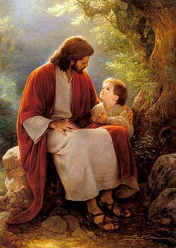
My Savior God to Thee

How great Thou art,
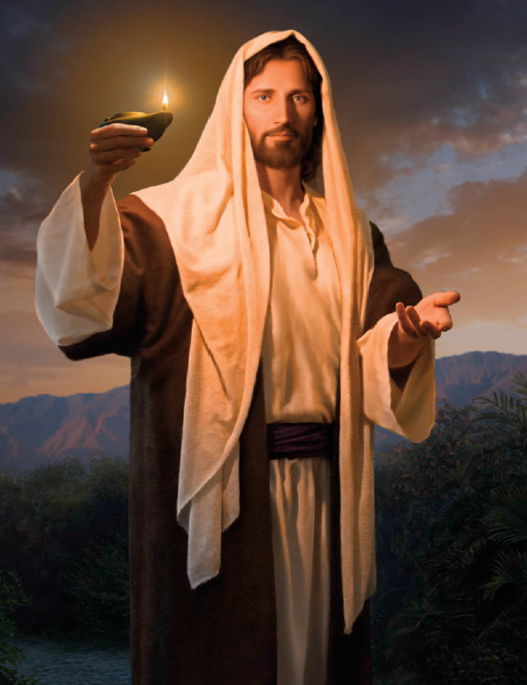
How great Thou art!

