I believe in Jesus
I know His words are true
He shares His love
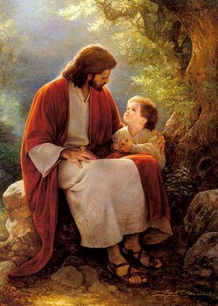
With ev’ryone and I will share love too
For I believe in Jesus
He teaches me each day
To trust in Him
To follow in His light
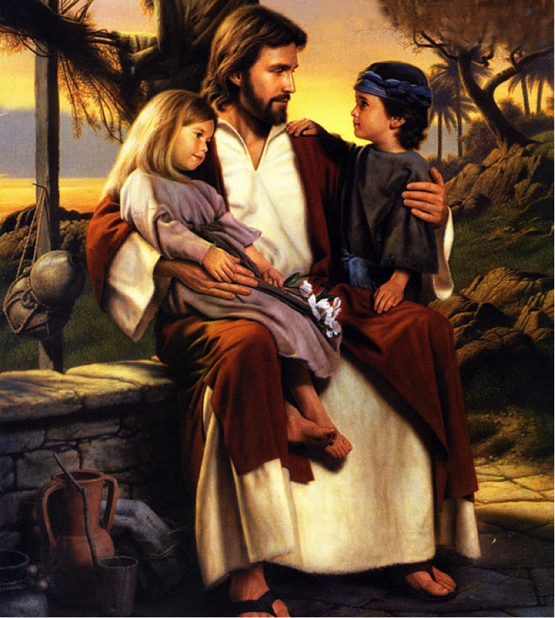
His Truth and His Way
I believe in Jesus
He leads me with His light
I’ll follow Him
Each day I live and I will choose the right
For I believe in Jesus
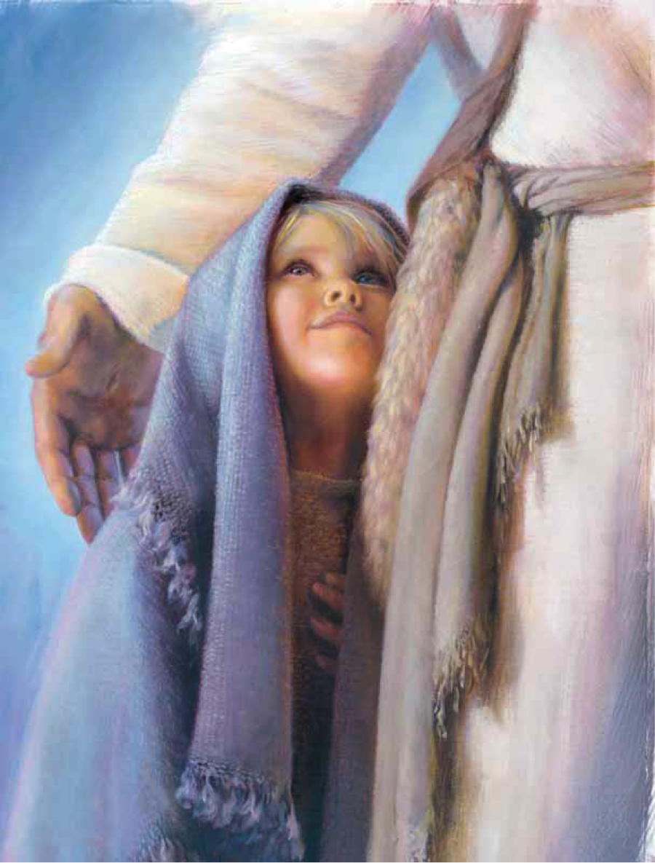
He teaches me each day
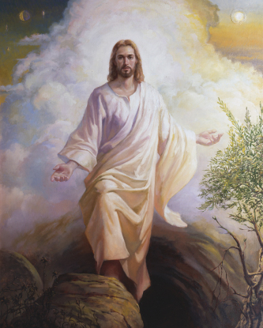
To trust in Him
To follow in His light
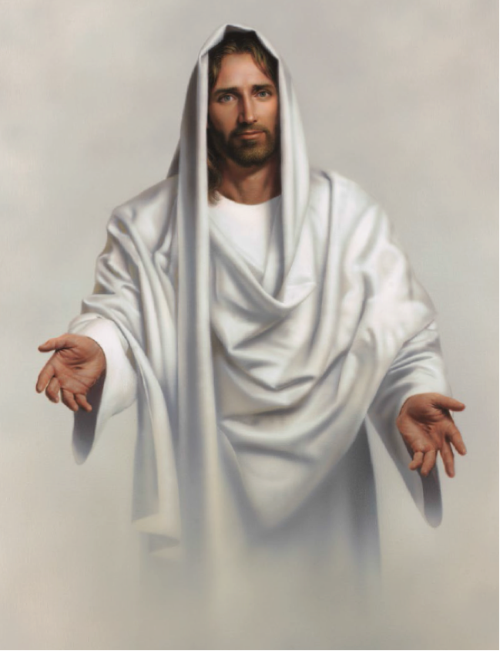
His Truth and His Way

