I Know the Scriptures are True

By Jenny N. Richards
PDF available on her website
http://jennyrichardsmusic.com/assets/i-know-the-scriptures-are-true.pdf

I know stories of far away places
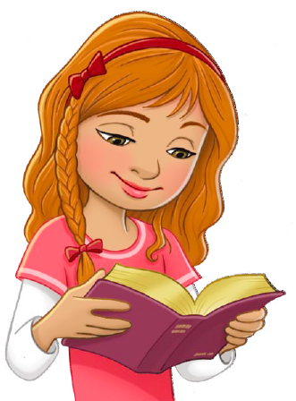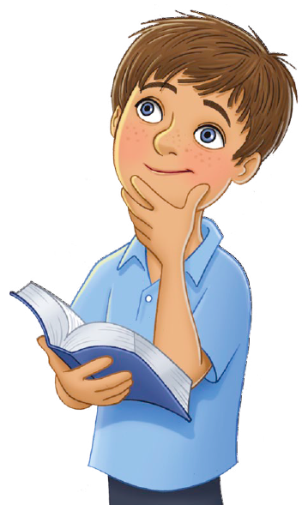
I know stories of long, long ago
I know stories of
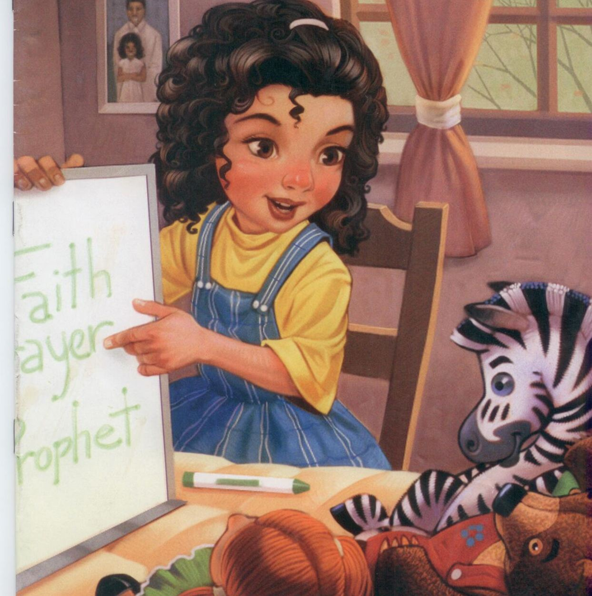
Faith and repentance
Told by prophets of old
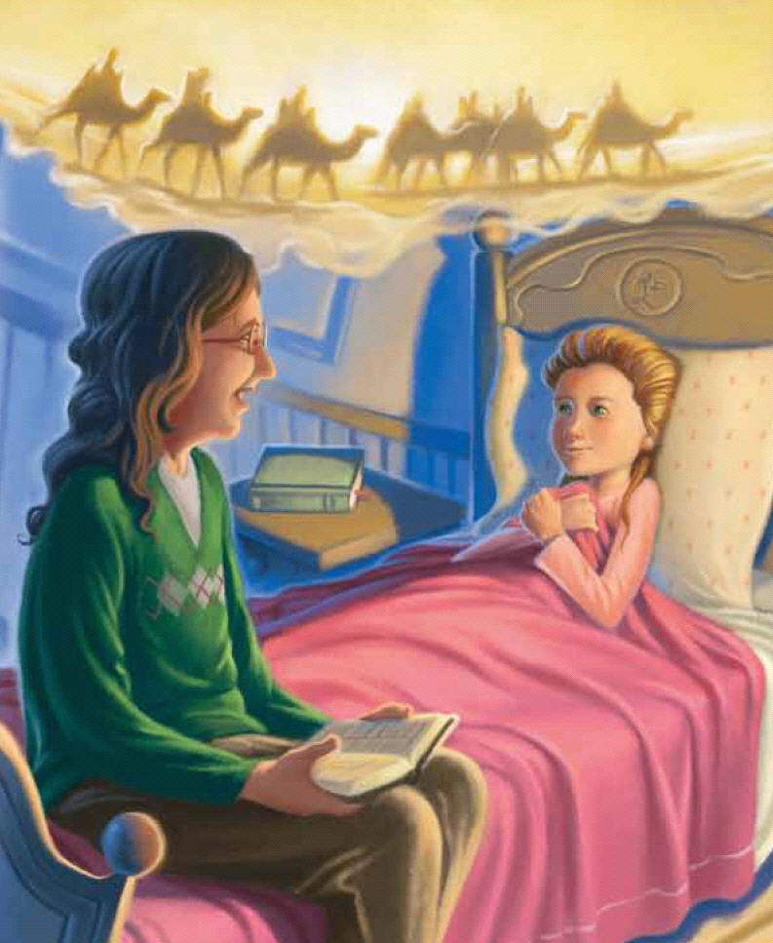
And I know they’re true!
And I know that
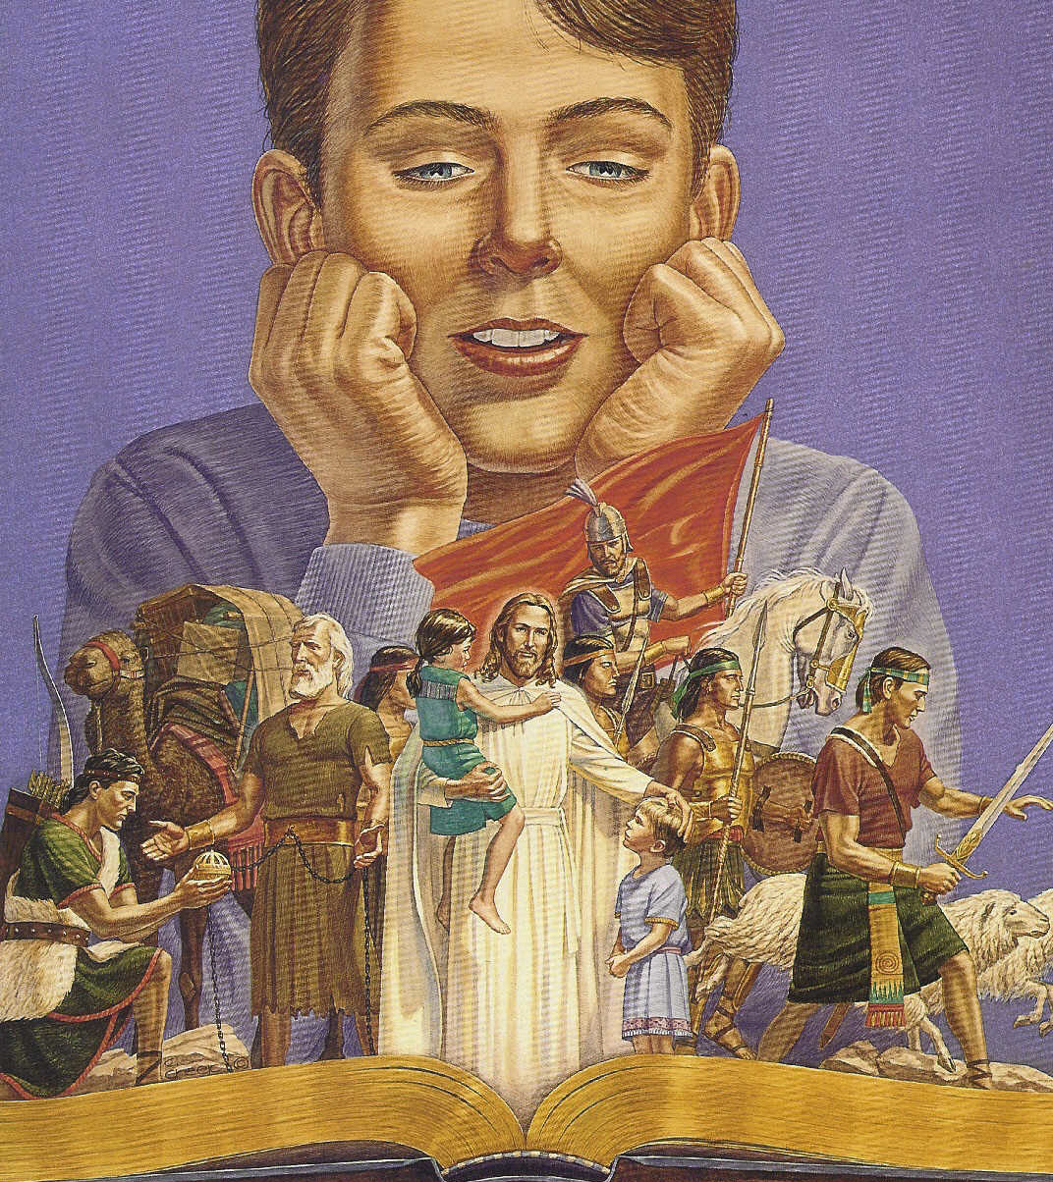
They were written for me
As I study, listen, learn, and obey
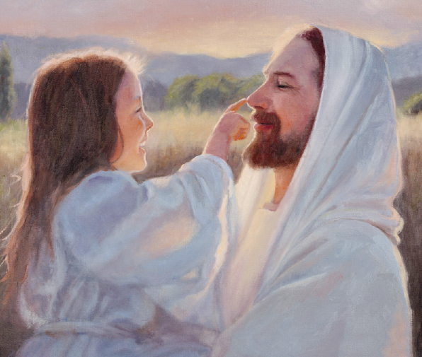
I can be more like Jesus
I have learned of a
prophet named Alma
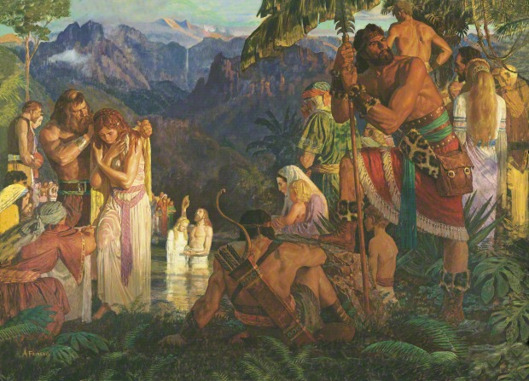
Who preached that
the gospel is true
And the story of Helaman’s warriors
Who had had mothers that knew
And I know they’re true!
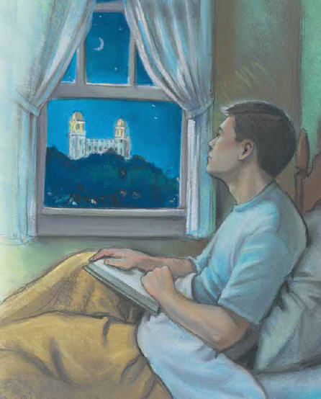
And I know that
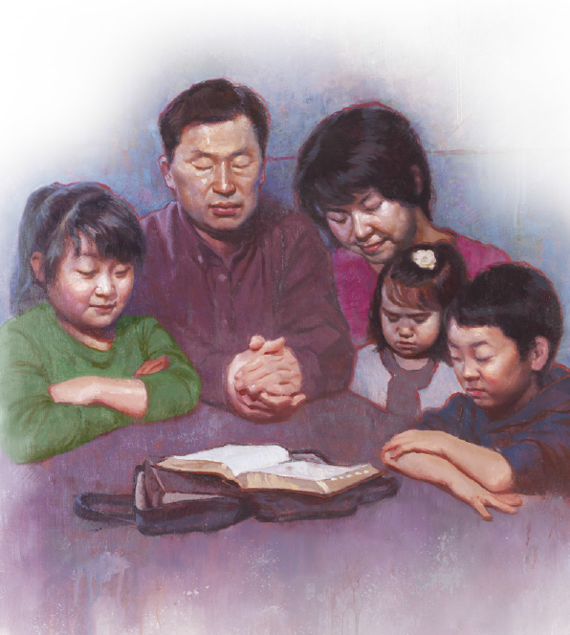
They were written for me
As I study, listen, learn, and obey
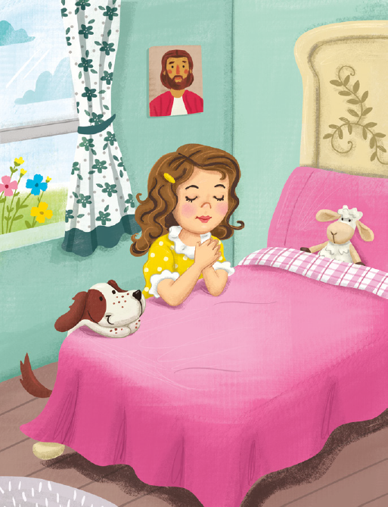
I can be more like Jesus
Stories teach me what I can be!
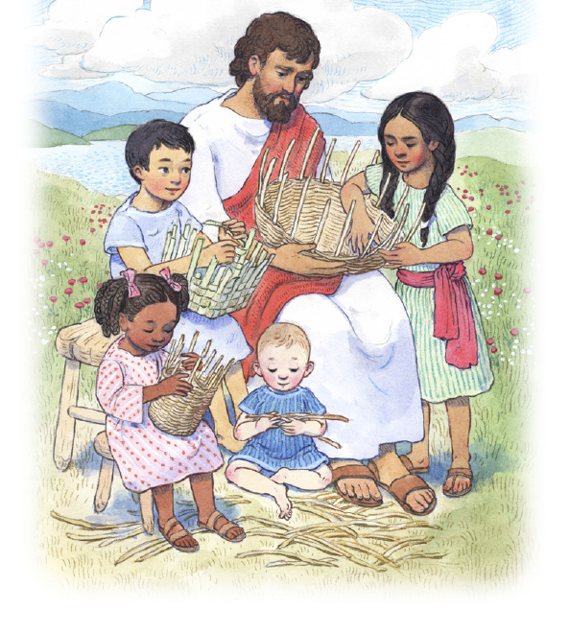
Stories teach me truths
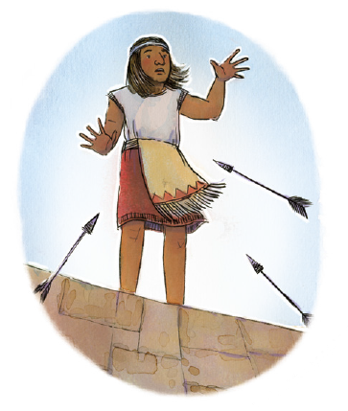
That can change me
In the scriptures I find many answers
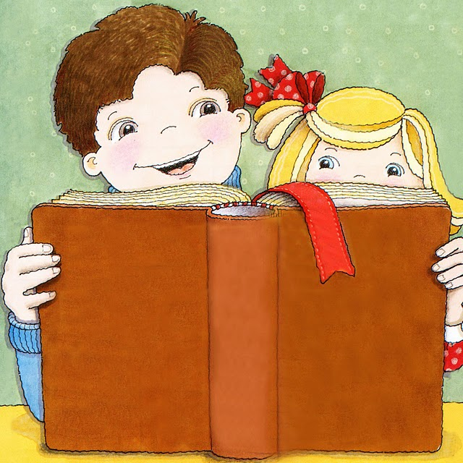
From stories that I hold so dear
They bring peace
They bring hope
They bring courage
As I follow and hear
And I know they’re true!
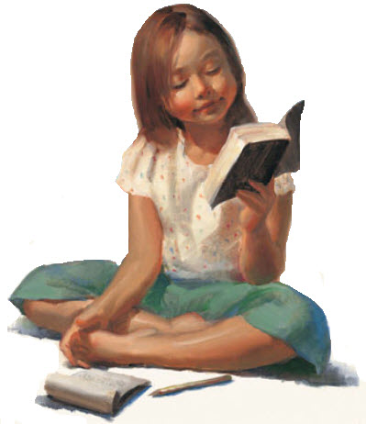
And I know that
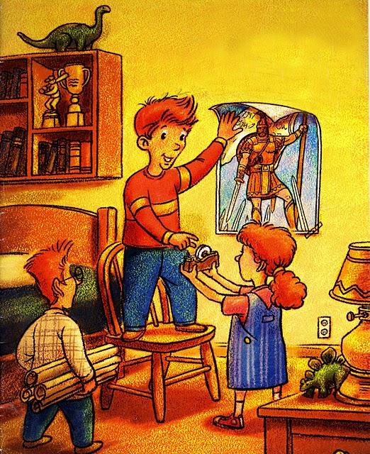
They were written for me
As I study, listen, learn, and obey
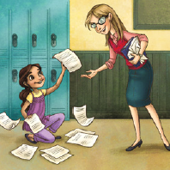
I can be more like Jesus

