My daddy is my fav’rite pal
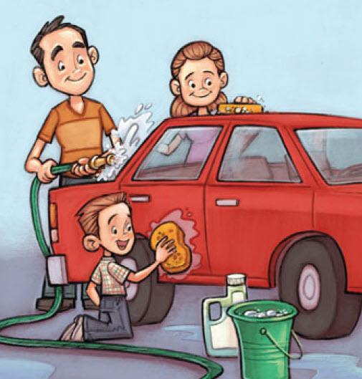
And I help him ev’ry day
It’s plain to see I want to be
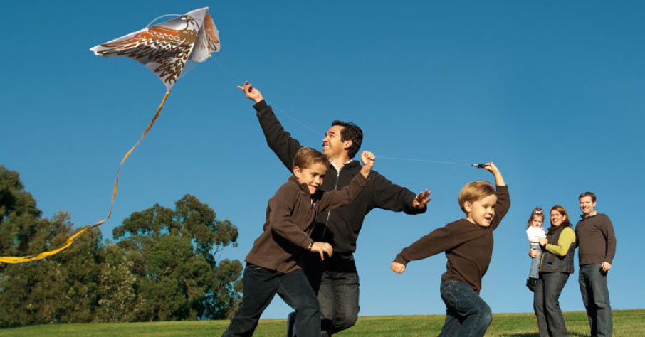Like him in ev’ry way
He teaches me that honesty
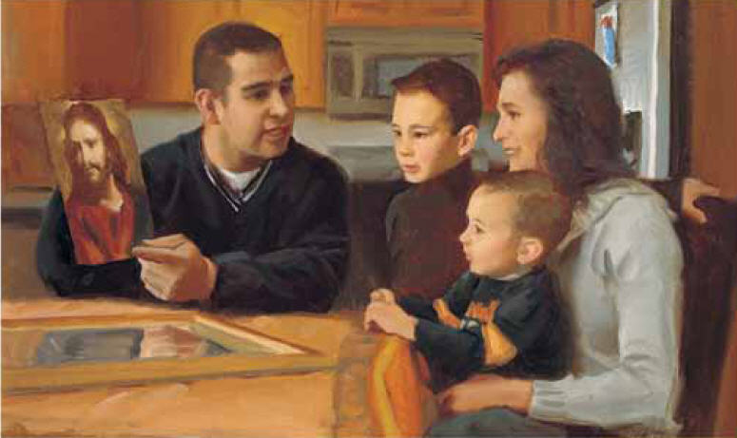
Is best in all I do

I’m very glad that he’s my dad
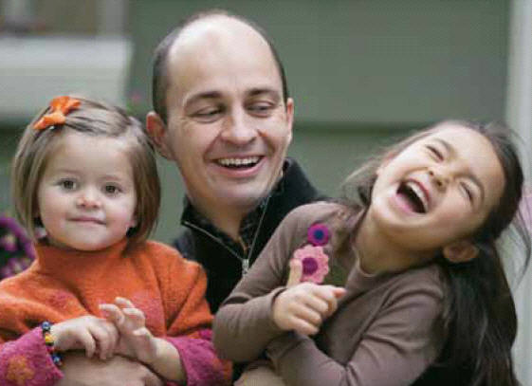
And I know he loves me too

