The Lord commanded Nephi to go and get the plates
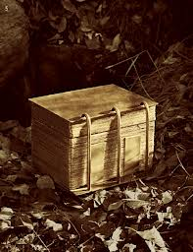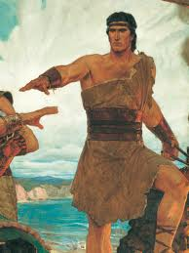
From the wicked Laban inside the city gates

Laman and Lemuel were both afraid to try
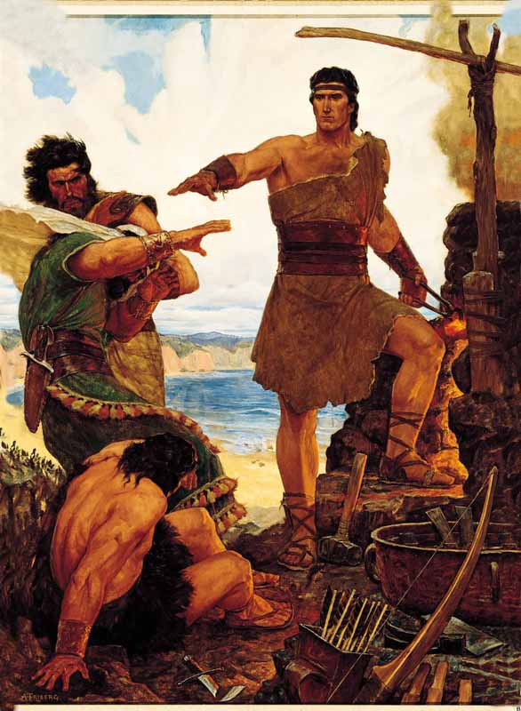
Nephi was courageous. This was his reply
The Lord commanded Nephi to go and build a boat
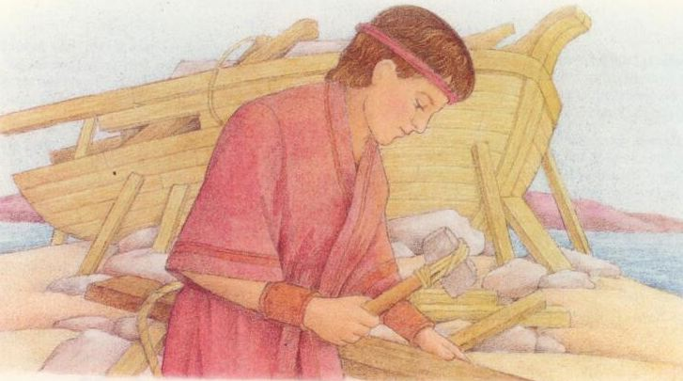
Nephi’s older brothers believed it would not float

Laughing and mocking, they said he should not try
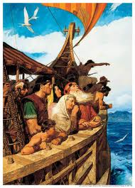
Nephi was courageous. This was his reply
The Lord gives us commandments and asks us to obey
Sometimes I am tempted to choose another way
When I’m discouraged, and think I cannot try
I will be courageous, and I will reply
I will go; I will do the thing the Lord commands
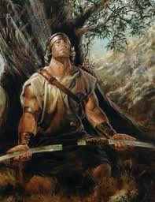
I know the Lord provides a way; he wants me to obey
I will go; I will do the thing the Lord commands
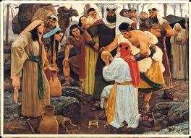
I know the Lord provides a way; he wants me to obey

