The Lord and Savior died for me
On the cross of Calvary
And suffered for me willingly
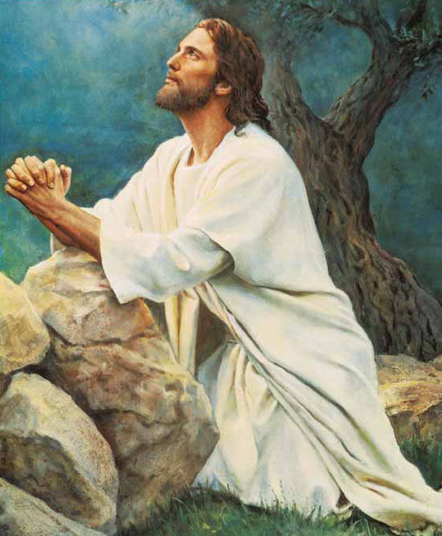
In the Garden of Gethsemane
Jesus paid for ev’ry wrong
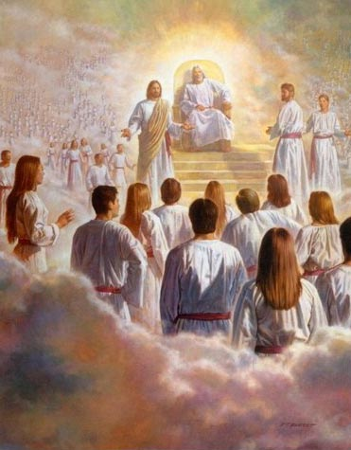
That’s why He was sent
He suffered pain the whole night long
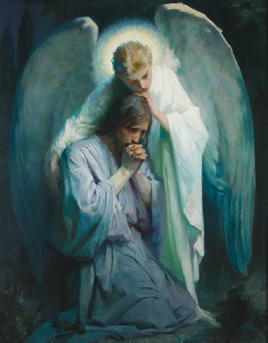
So we could all repent
My Savior sacrificed
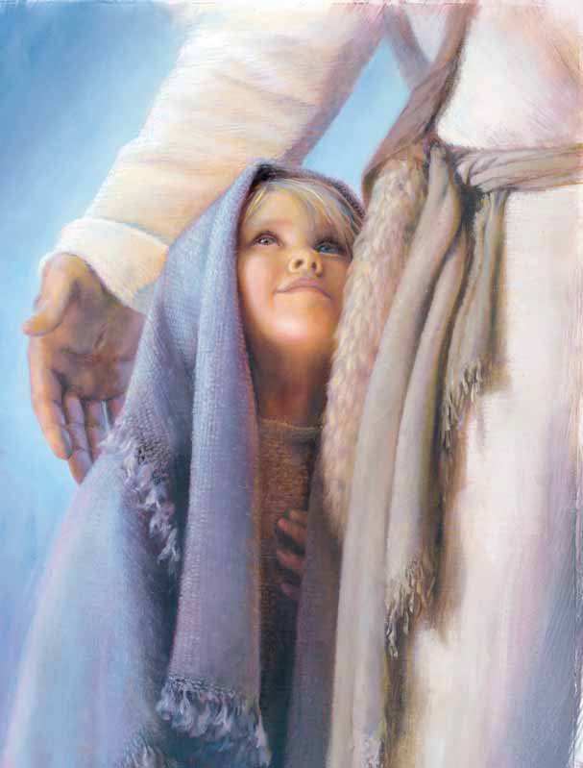
I know He paid the price
And I know He did it willingly for me
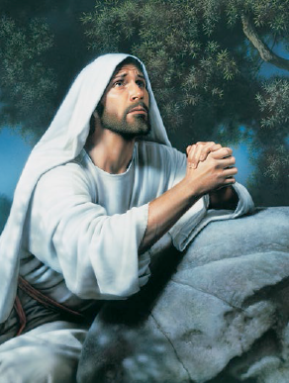
In the lonely night of Gethsemane
I think of His atonement
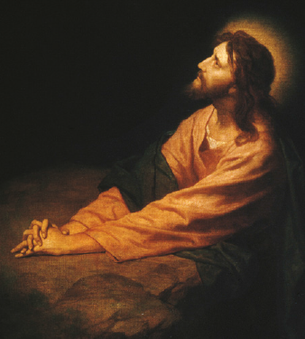
I think about His pain
Because my Savior died for me
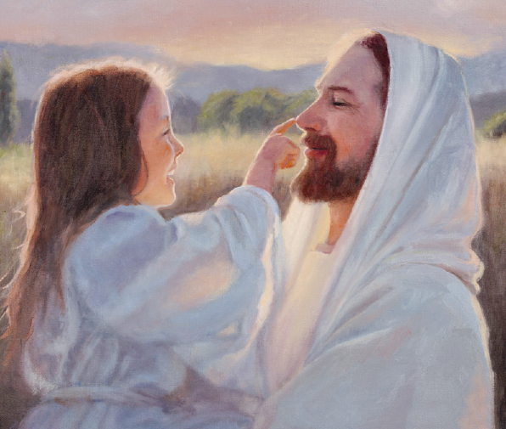
I know I’ll live again

