When my mother
calls me
Quickly I’ll obey

I want to do just what is best
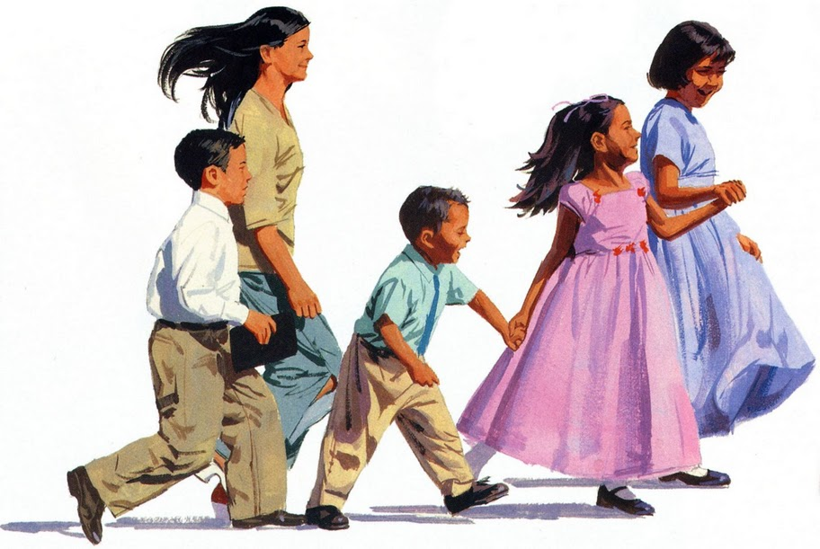
Each and ev’ry day

When my father calls me,
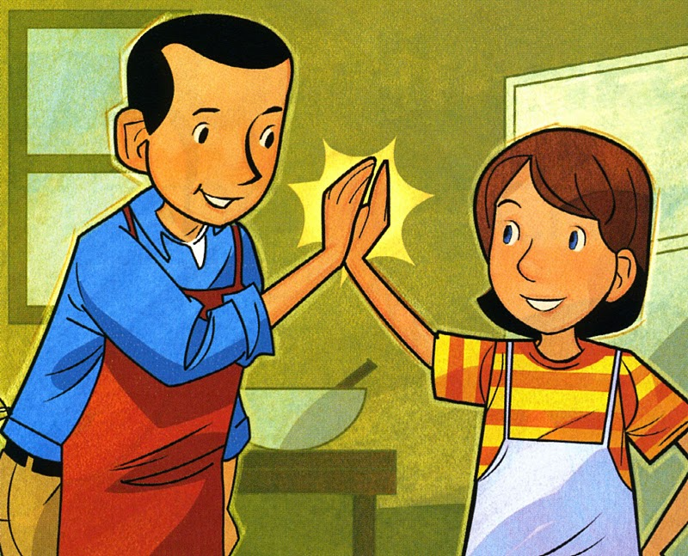
Quickly I’ll obey

Heav’nly Father loves me
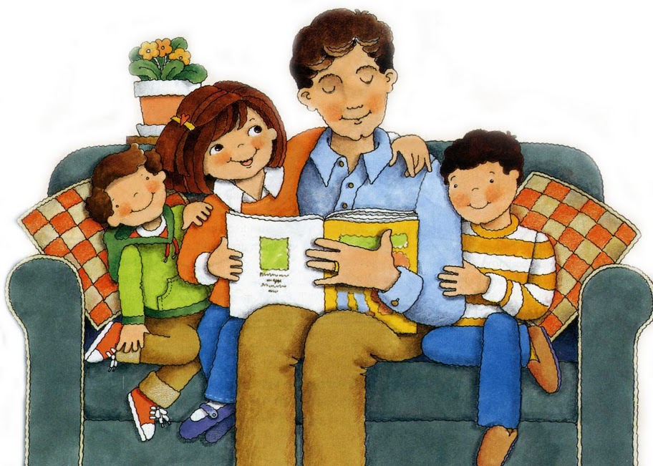
Blesses me each day

