Rev’rence is more than just quietly sitting
It’s thinking of Father above
A feeling I get when I think of his blessings
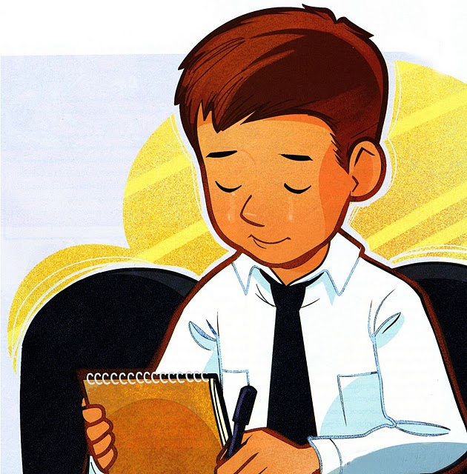
I’m reverent for rev’rence is love
When I’m rev’rent it shows in my words and my deeds
The pathway to follow is clear
And when I am rev’rent I know in my heart
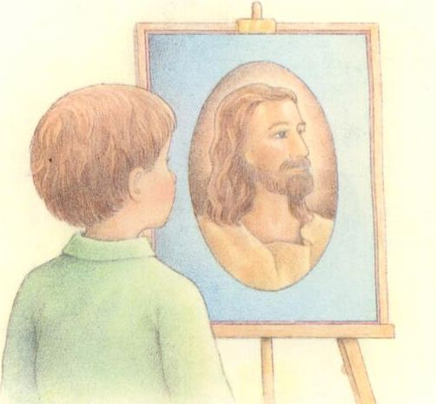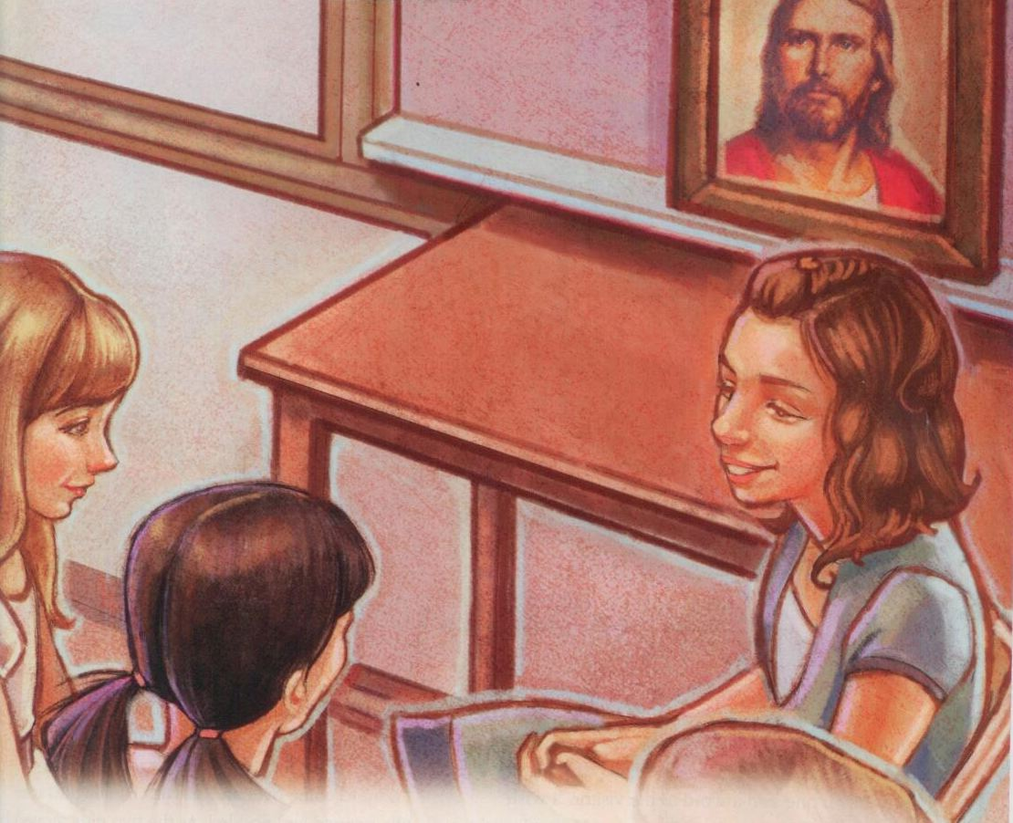
Heav’nly Father and Jesus are near

