Sacred names of Jesus Christ
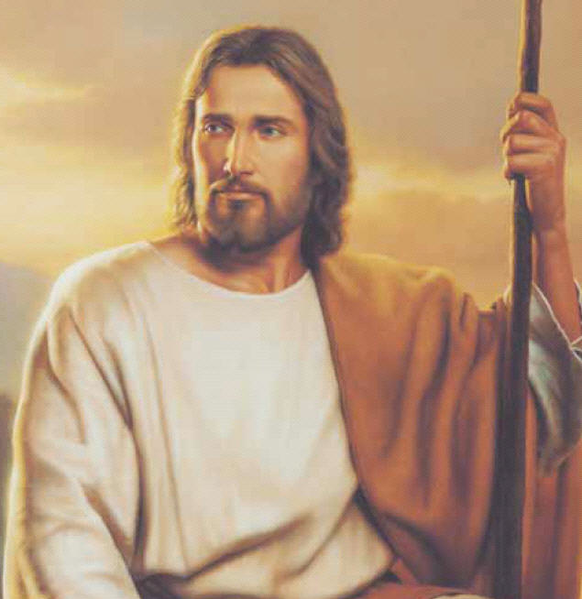
I say them with great care
When I speak these names of God
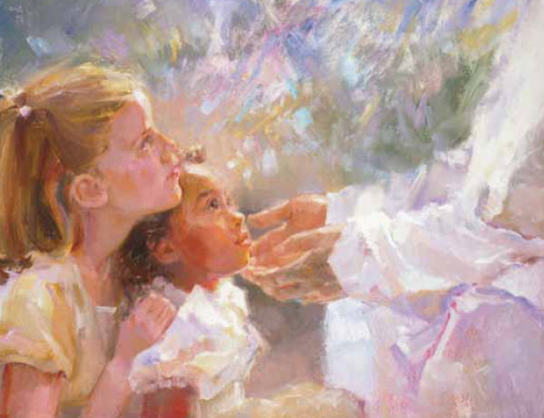
I speak as if in prayer
Messiah, Light, the Savior,
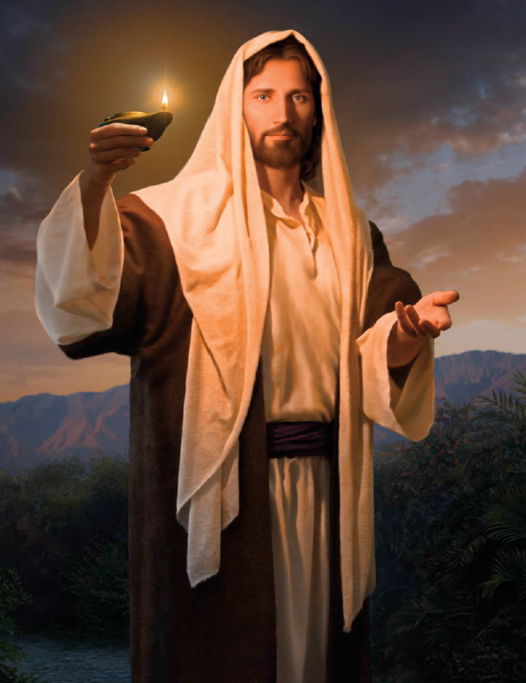
Good Shepherd, Holy One,
Prince of Peace, the Lamb of God,
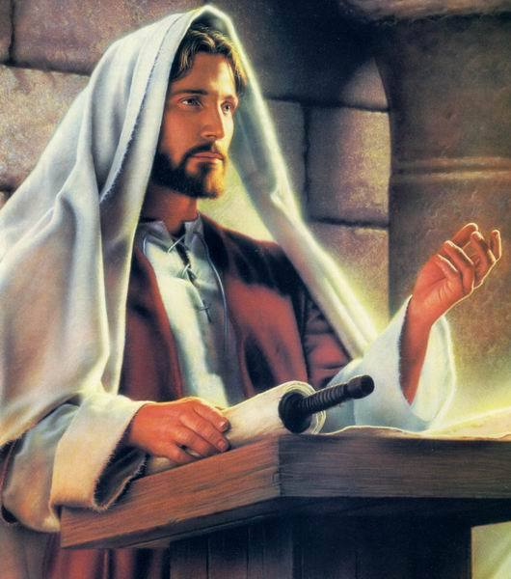
Jehovah, Lord, the Son

