Saturday is a special day
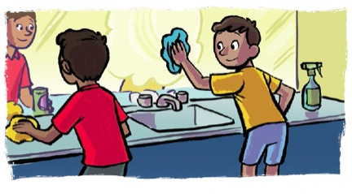
It's the day we get ready for Sunday
We clean the house,
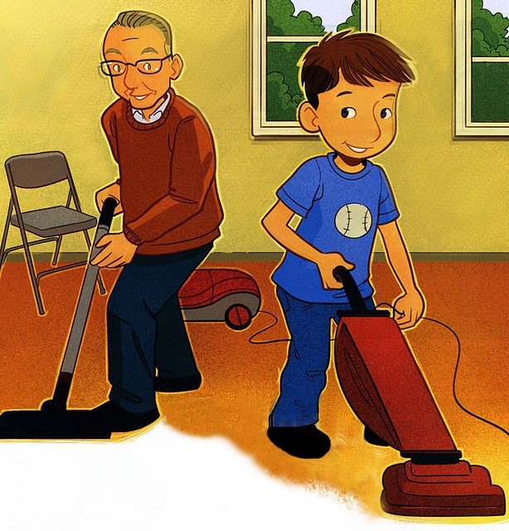
And we shop at the store
So we won't have to work until Monday
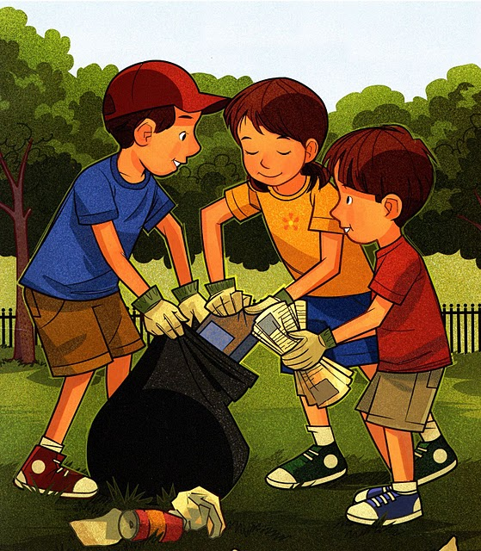
We brush our clothes
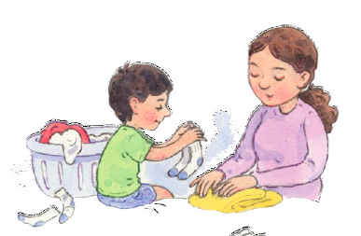
And we shine our shoes
And we call it
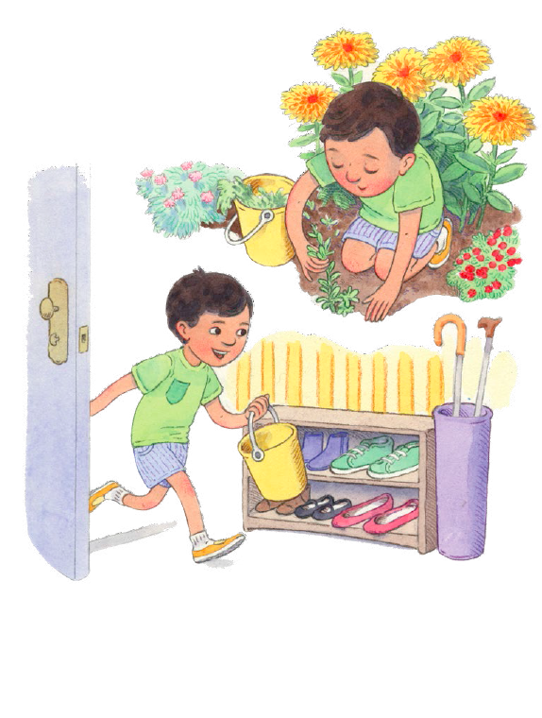
Our get-the-work-done day
Then we trim our nails
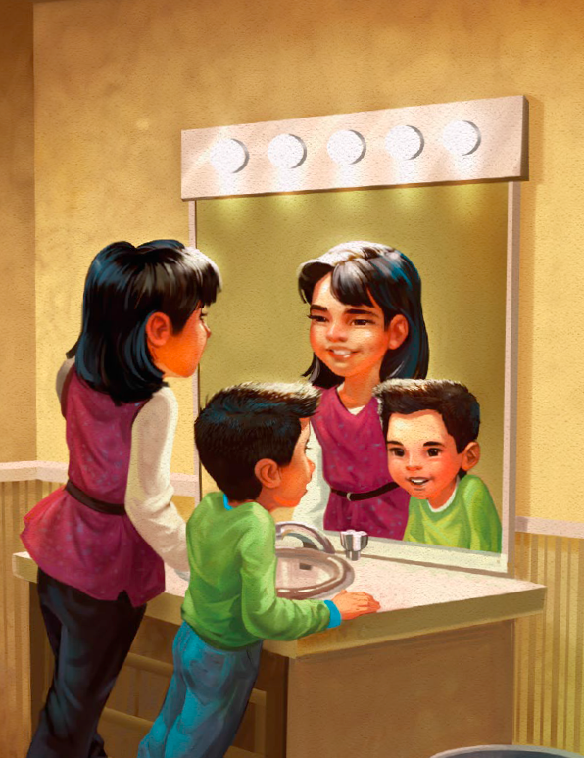
And we shampoo our hair
So we can be ready for Sunday!
