My light is but a little one

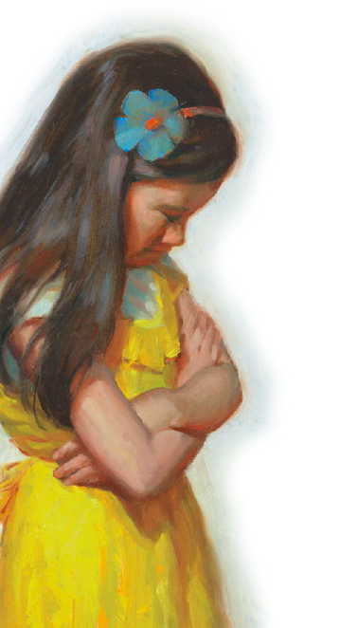

My light of faith and prayer

But lo! it glows like God's great sun

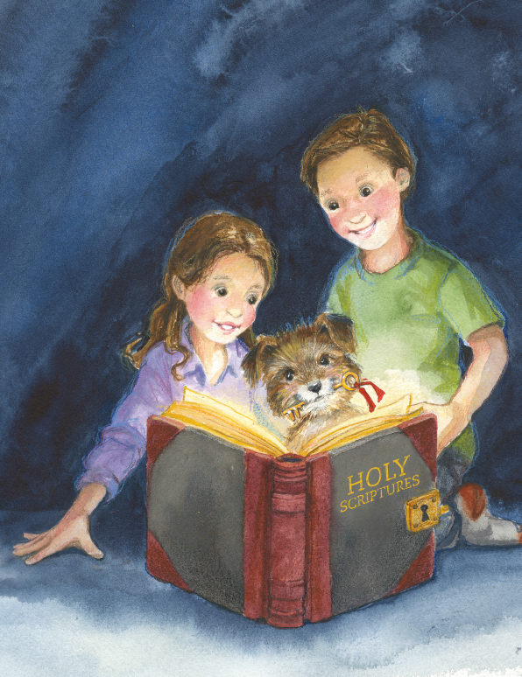

For it was lighted there

I may not hide my little light

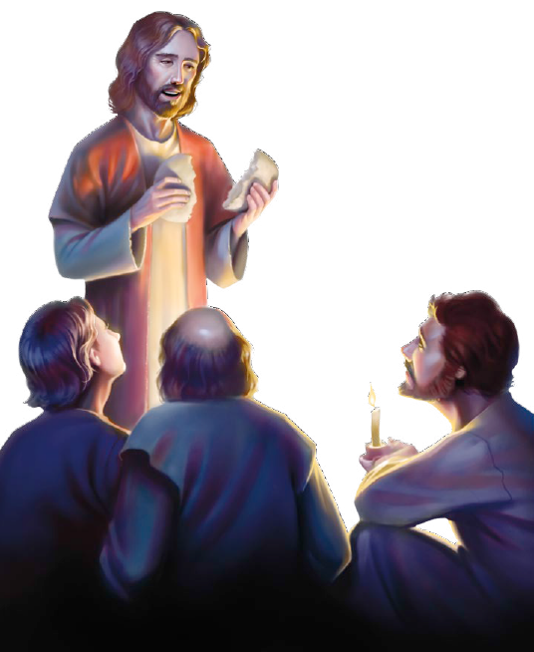

The Lord has told me so

'Tis given me to keep in sight



That all may see it glow

Shine on, shine on,

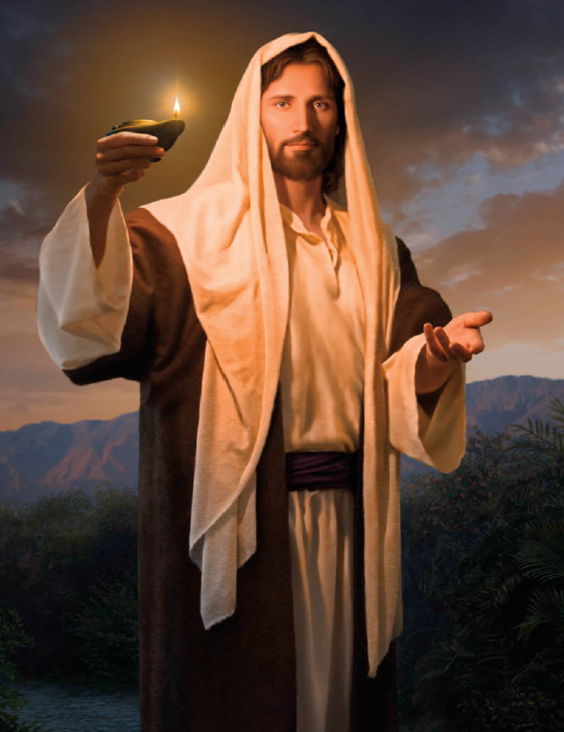

Shine on bright and clear

Shine on, shine on

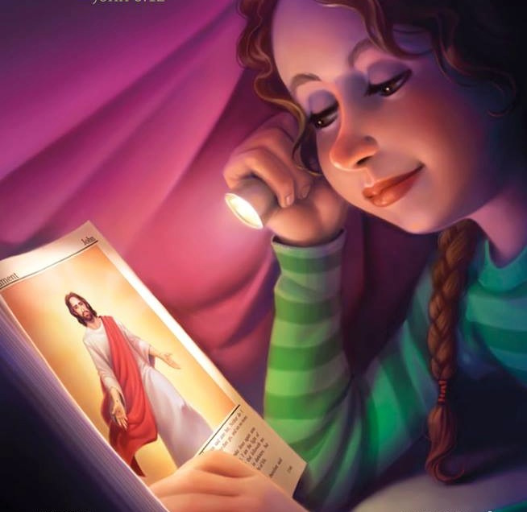

Now the day is here