The Book of Mormon teaches me
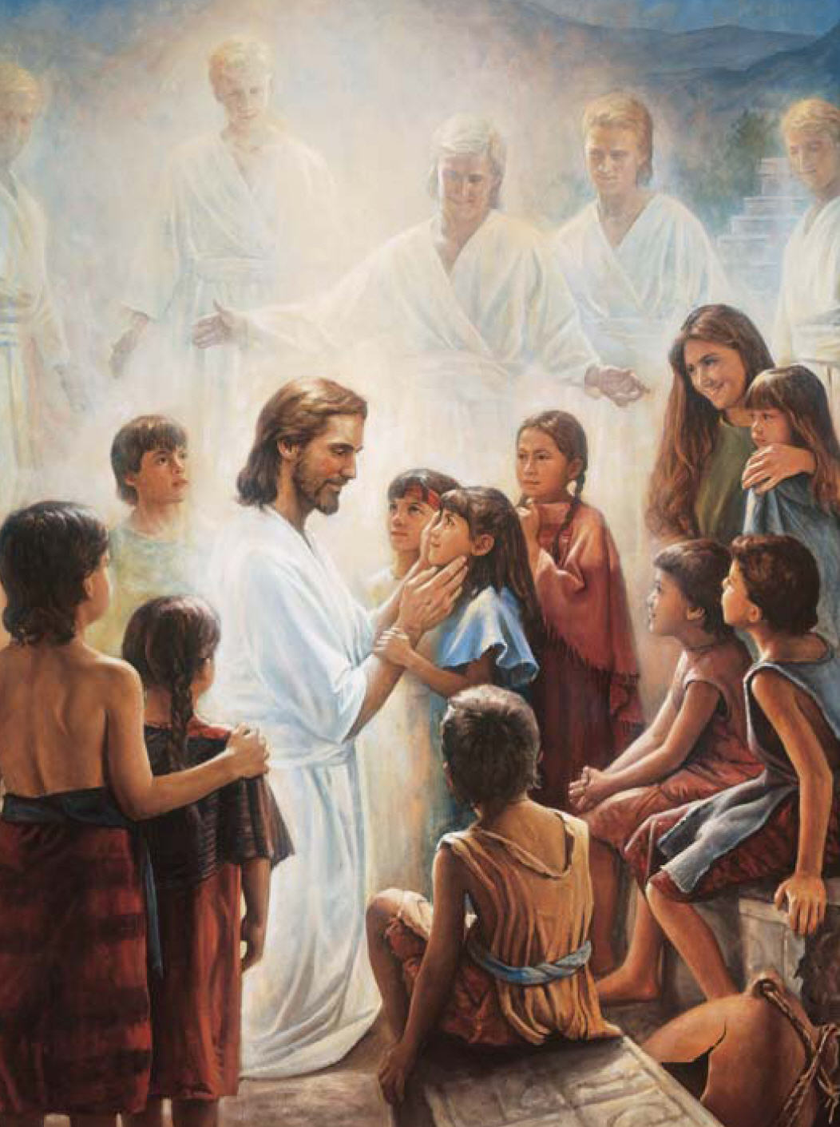
That Jesus is the Christ
He lived and died for you and me
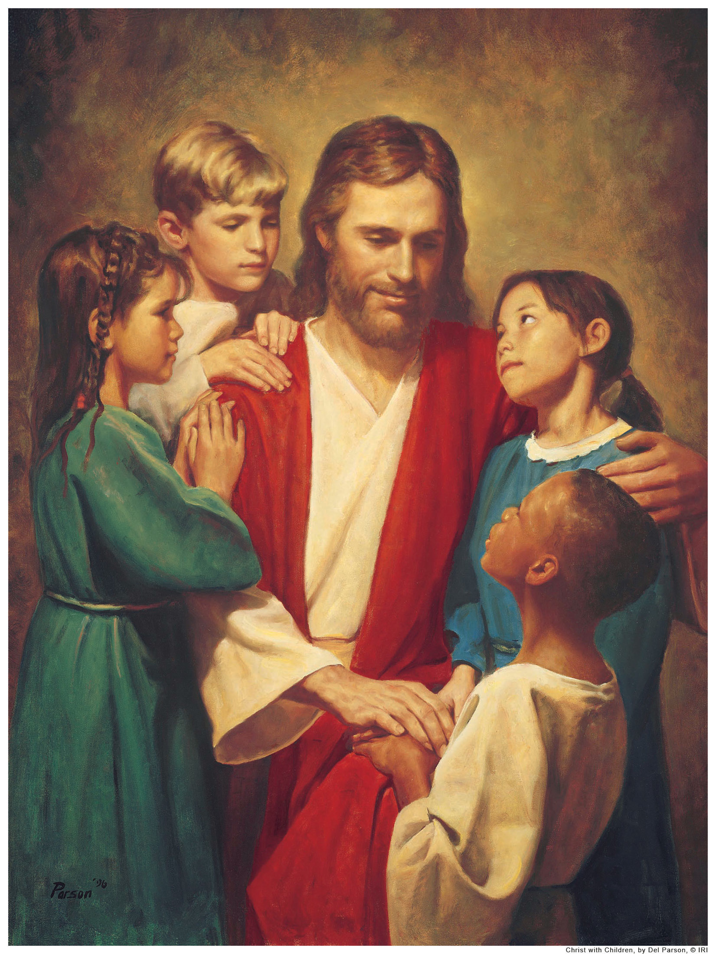
With love He sacrificed
It says I must have faith, repent,
And live the Savior’s word
It is another testament
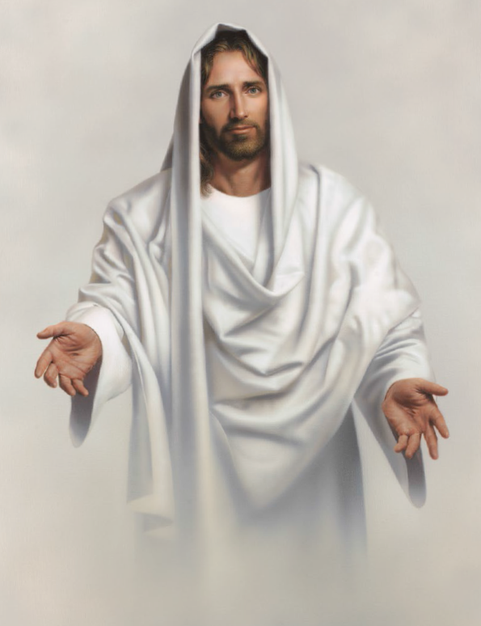
Of Jesus Christ our Lord
The Book of Mormon helps me see
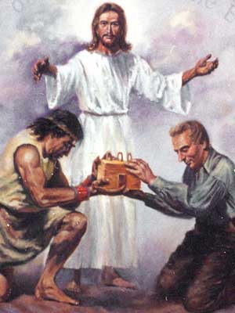
That truth has been restored
That Joseph Smith was called to be
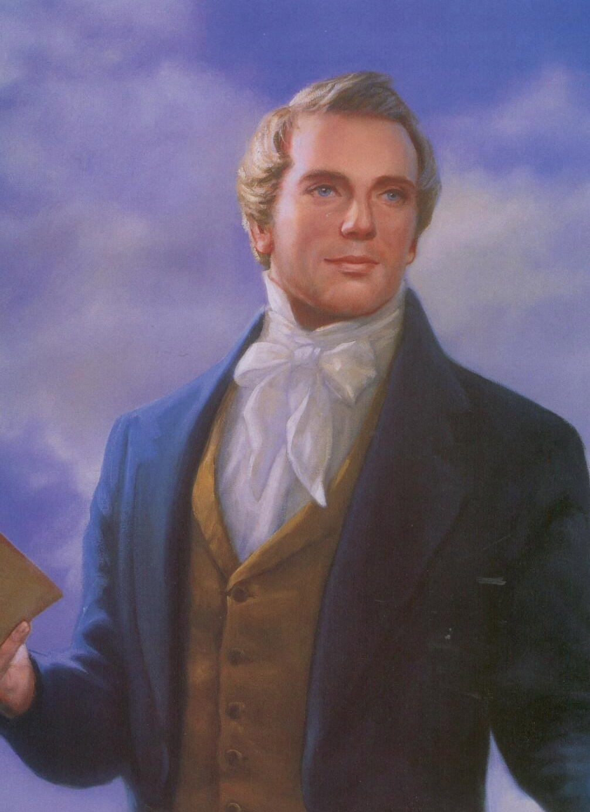
A prophet of the Lord
The book reveals God’s covenant
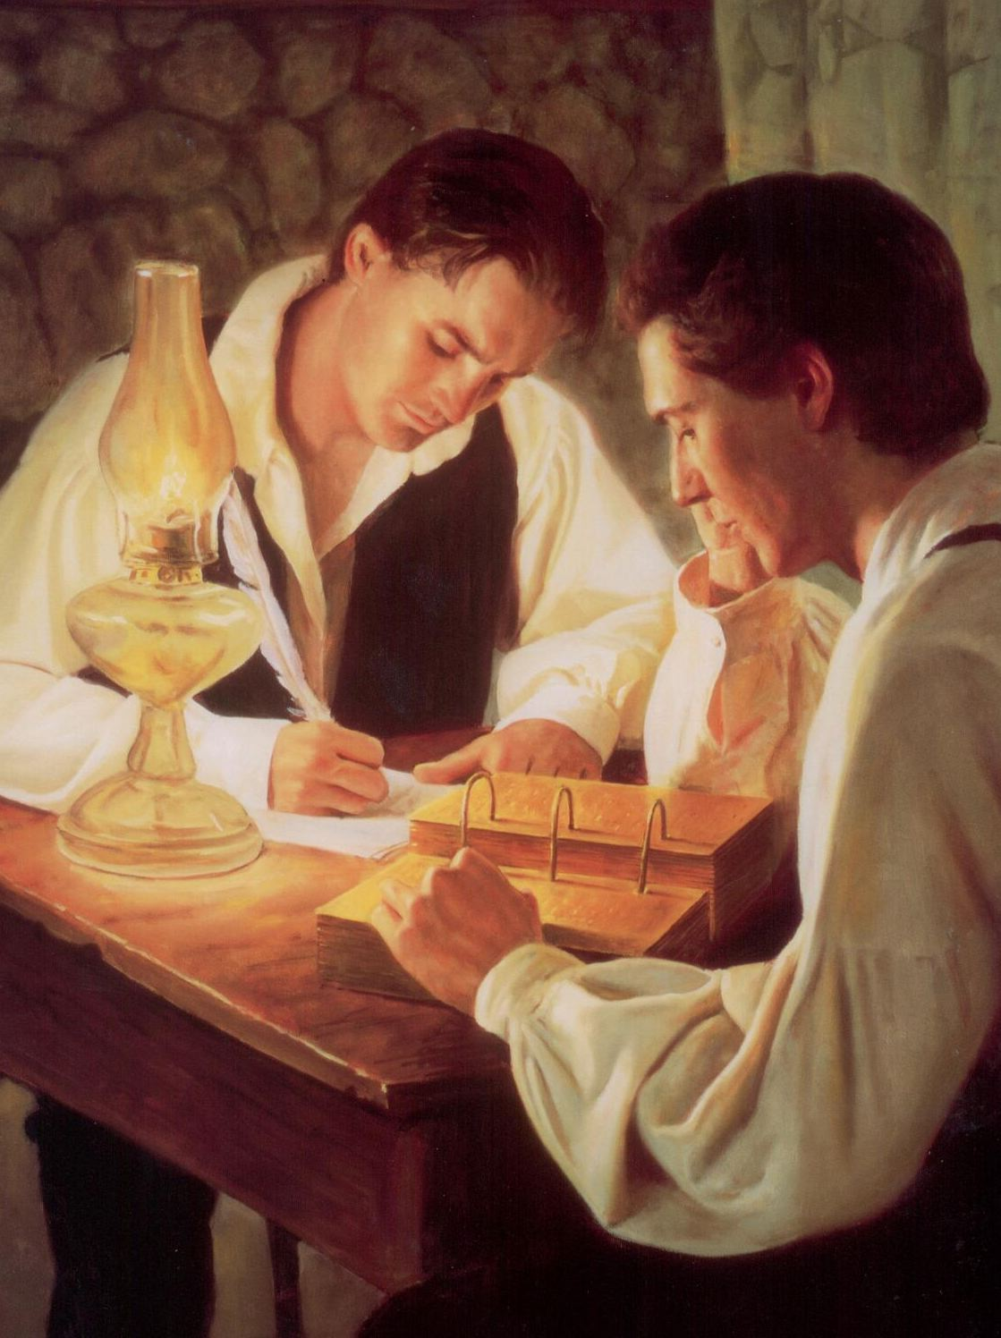
The fulness of His word
It is another testament
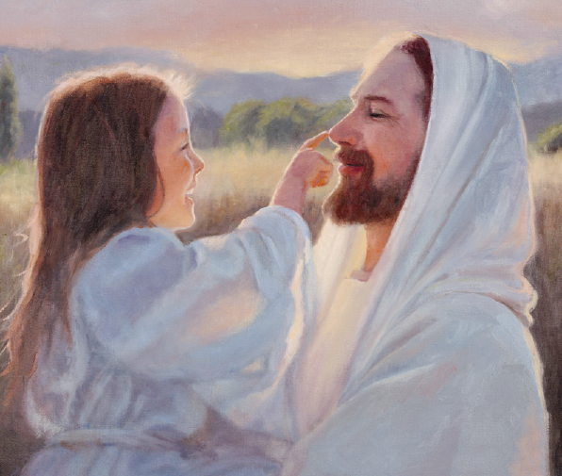
Of Jesus Christ our Lord
I’ll read the Book of Mormon, then
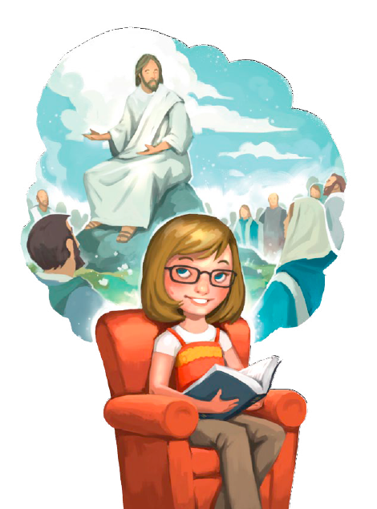
I’ll pray and ponder too
I’ll put my faith in Jesus when
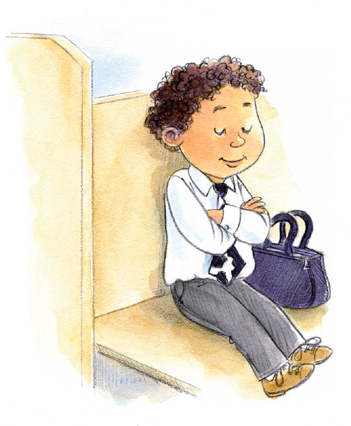
I ask if it is true
And when I pray with pure intent
I’ll hear the Spirit’s word
It is another testament
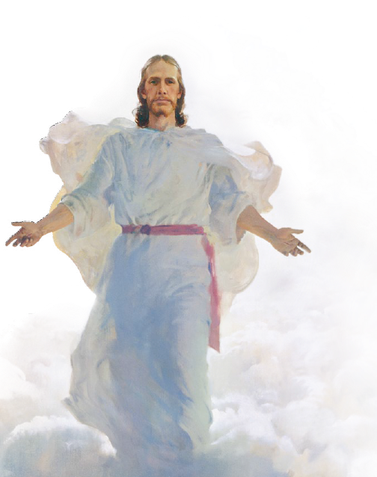
Of Jesus Christ our Lord

