- To Nephi seer of olden time
- 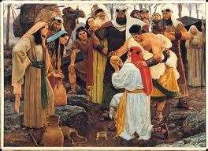
- A vision came from God
- Wherein the holy word sublime
- 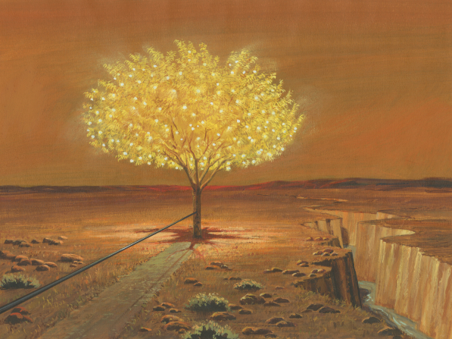
- Was shown an iron rod
- Hold to the rod the iron rod
- 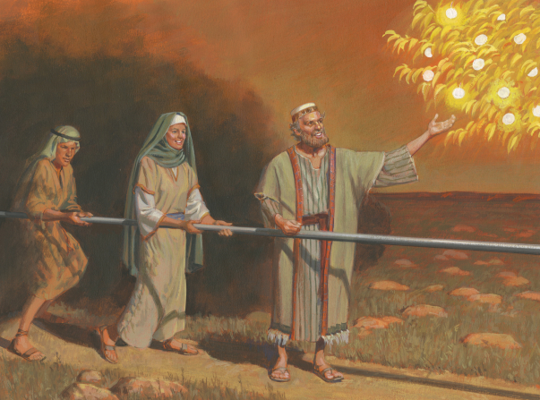
- 'Tis strong and bright and true
- The iron rod is the word of God
- 'Twill safely guide us through
- While on our journey here below
- Beneath temptation's pow'r
- Through mists of darkness we must go
- In peril ev'ry hour
And when temptation's pow'r is nigh
Our pathway clouded o'er
Upon the rod we can rely
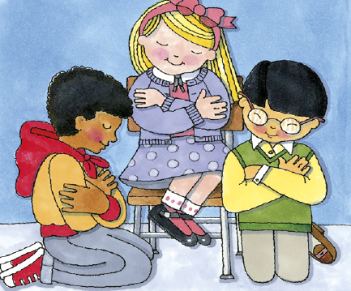
And heaven's aid implore

