The Lord gave me a temple
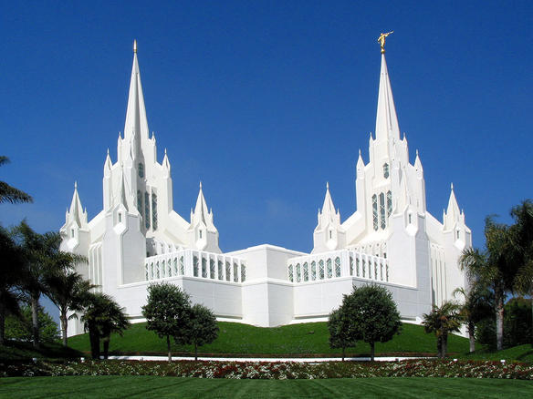
To live within on earth
Once in Heaven I was spirit
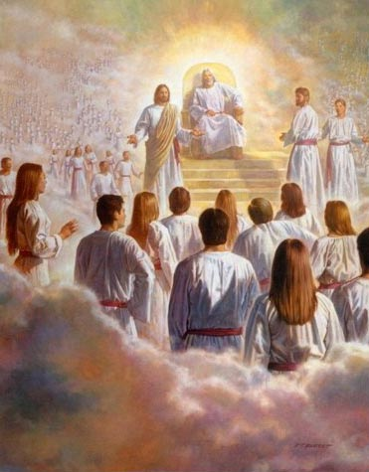
But I left my home at birth
I’ll make my temple brighter
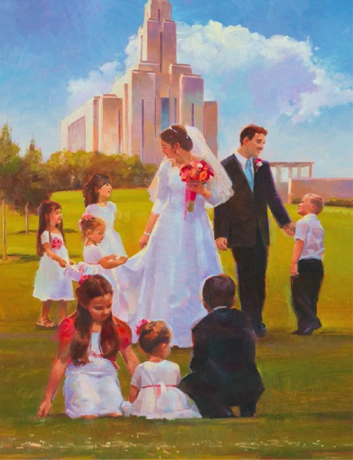
I’ll keep my spirit free
My body is the temple
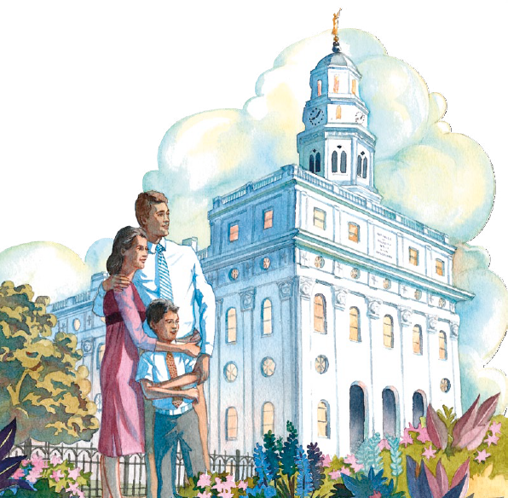
My Father gave to me
If I keep my body 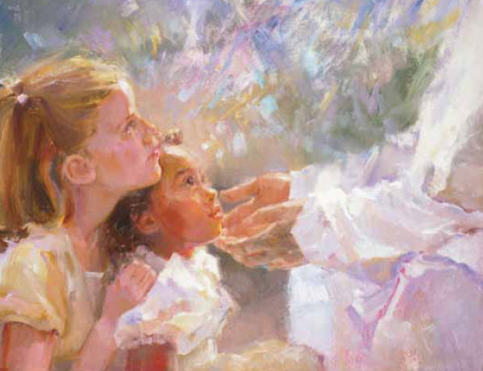
Clean and pure and habit free
I may in Father’s temple
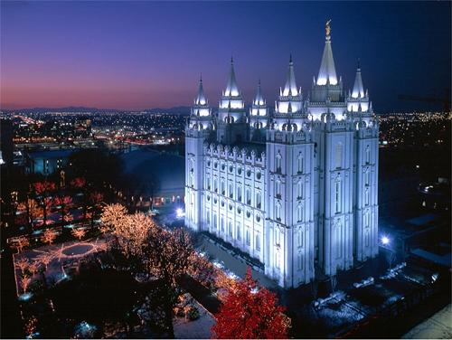
Claim blessings promised me
On resurrection morning
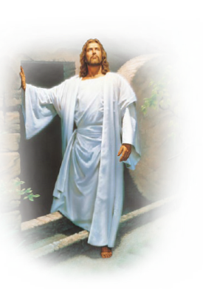
I’ll take my body bright
And in celestial glory
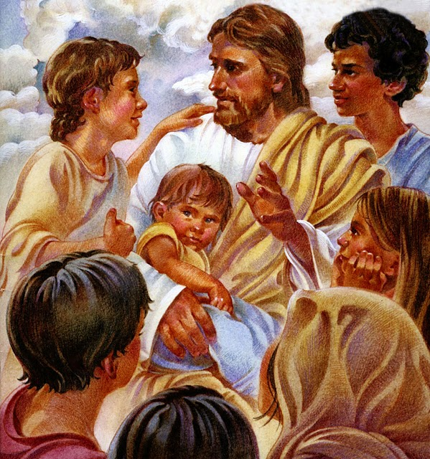
Forever live in light

