The wise man built his house

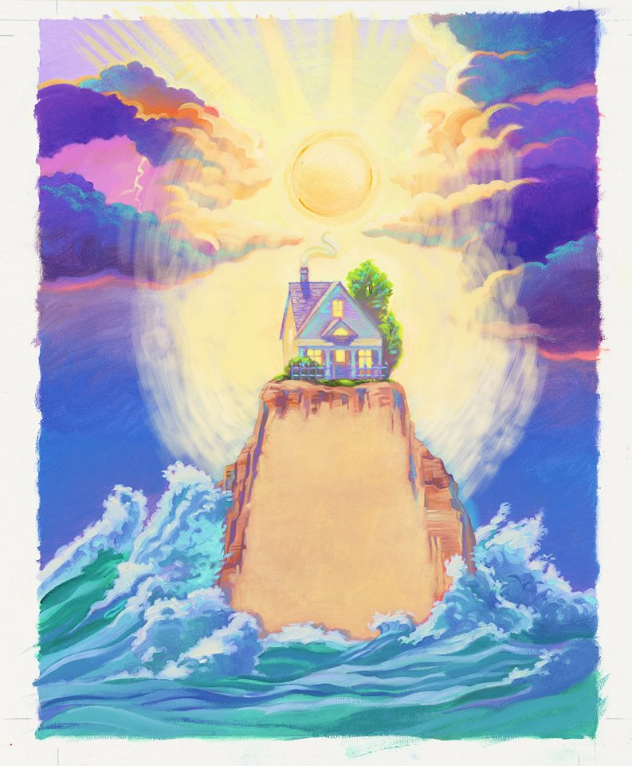

upon the *rock*

And the *rains* came tumbling down



The *rains* came down

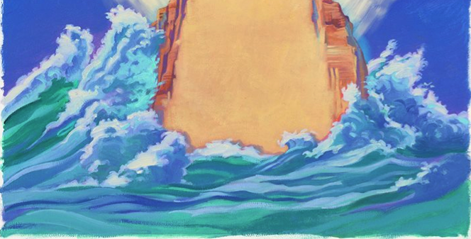

And the *floods* came up

And the house on the *rock* stood still.



The foolish man built his house

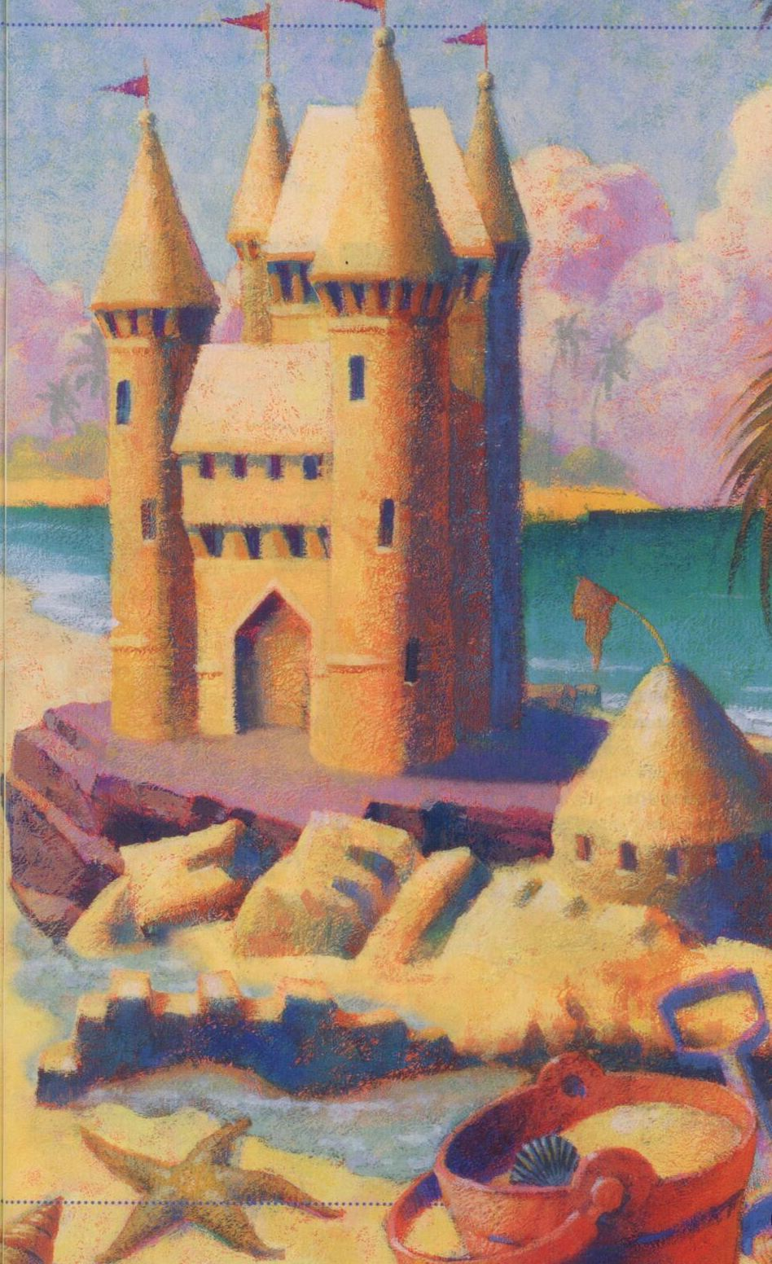

upon the *sand*

And the *rains* came tumbling down

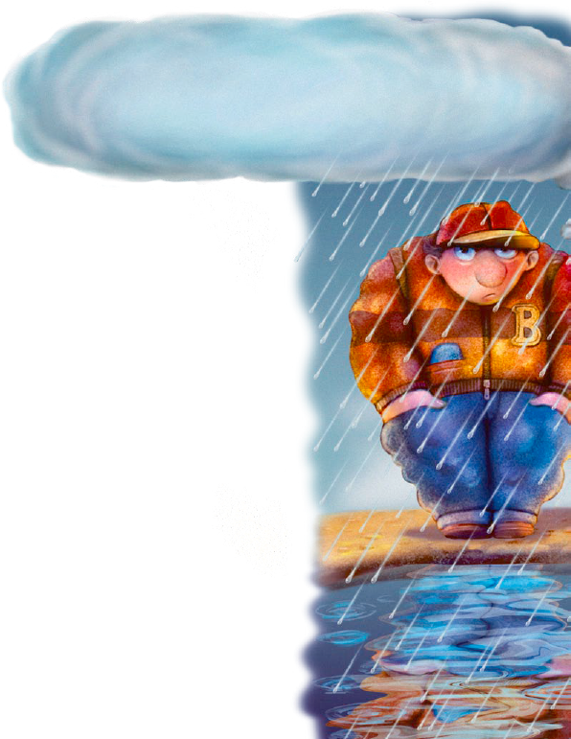

The *rains* came down



And the *floods* came up,

And the house on the *sand*

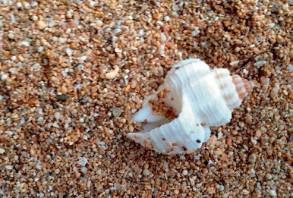

*washed away*