Whenever I think about pioneers,
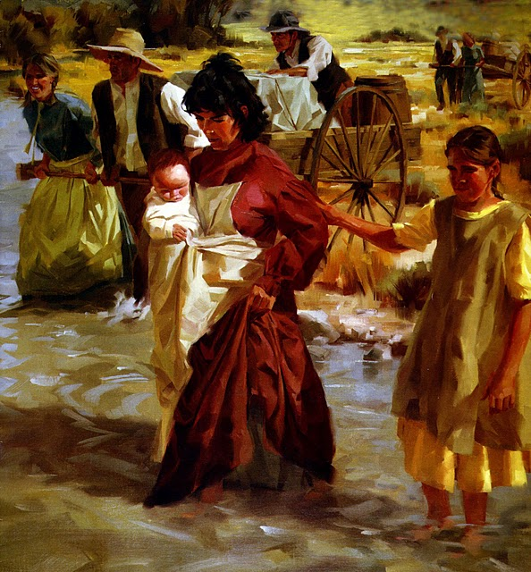
I think of brave women and men
I like to remember that children came, too
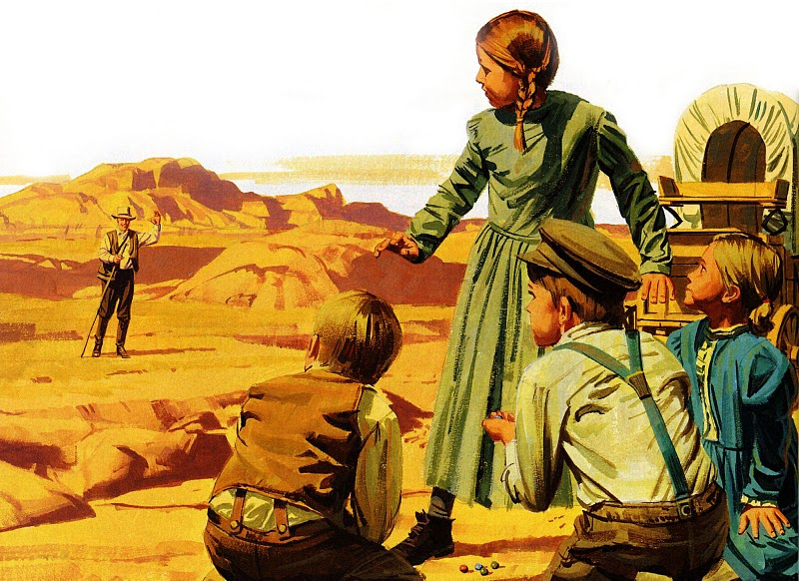
I would like to have been a child then
Yes, I’d like to have learned to play the games they played
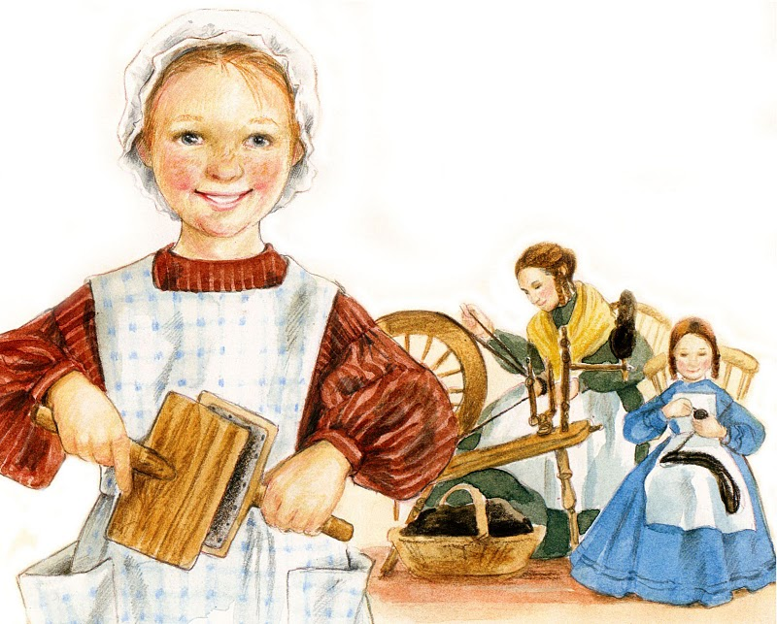
And joined them in their fun
And I’d like to have slept under bright starry skies
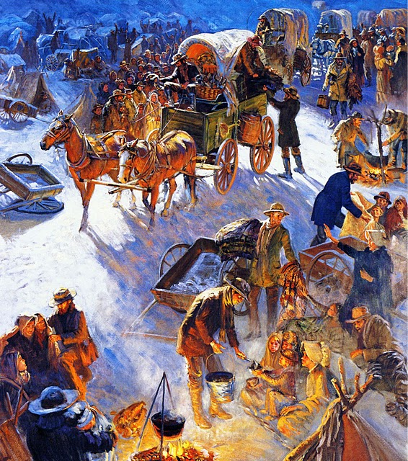
When each day’s measured journey was done
I would like to have sung with all the pioneers
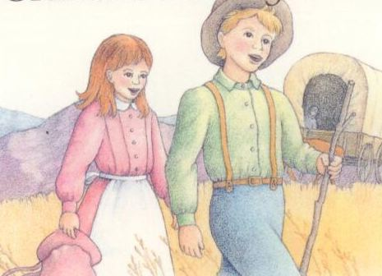
With voices loud and strong
“Hosanna, Hosanna, we’ve found our new home,”
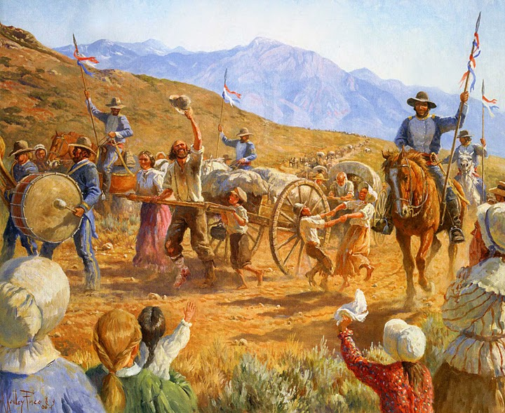
Joy and thankfulness filling their song
I would like to have sung with the pioneers
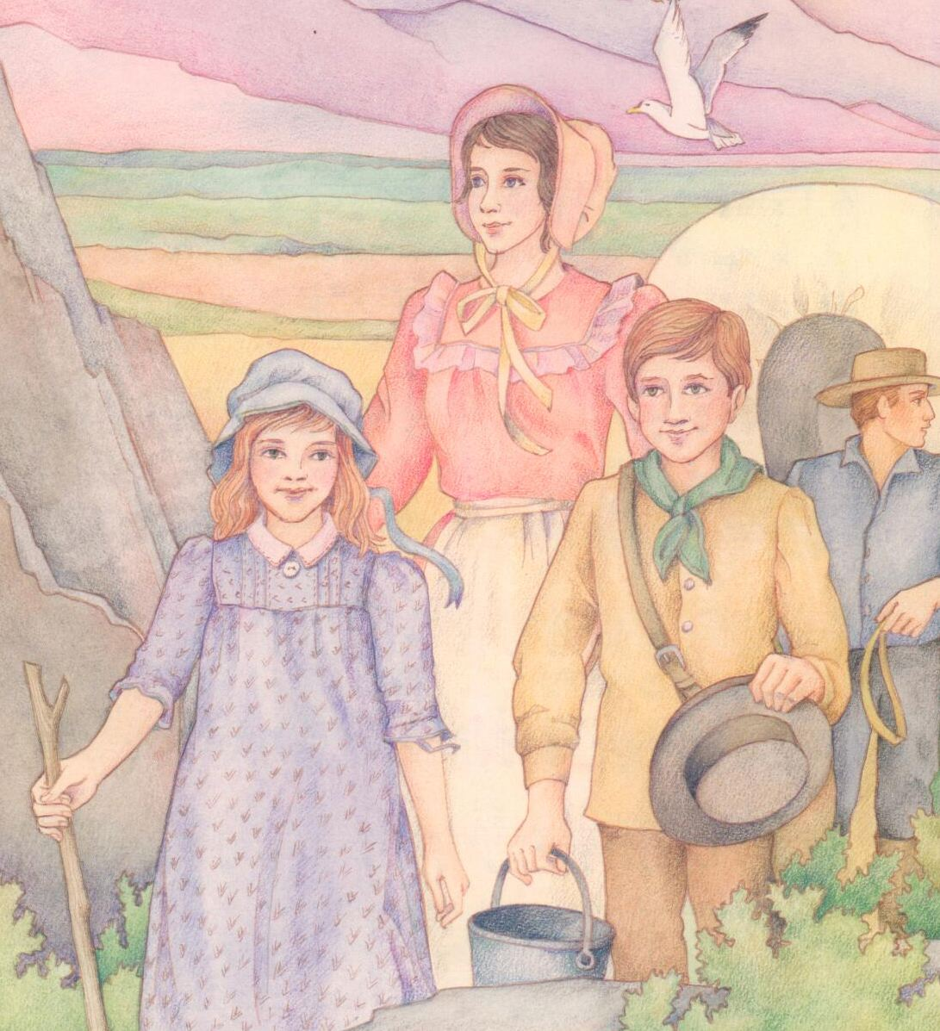
When voices rang out loud and strong
“Hosanna, Hosanna, we’ve found our new home,”
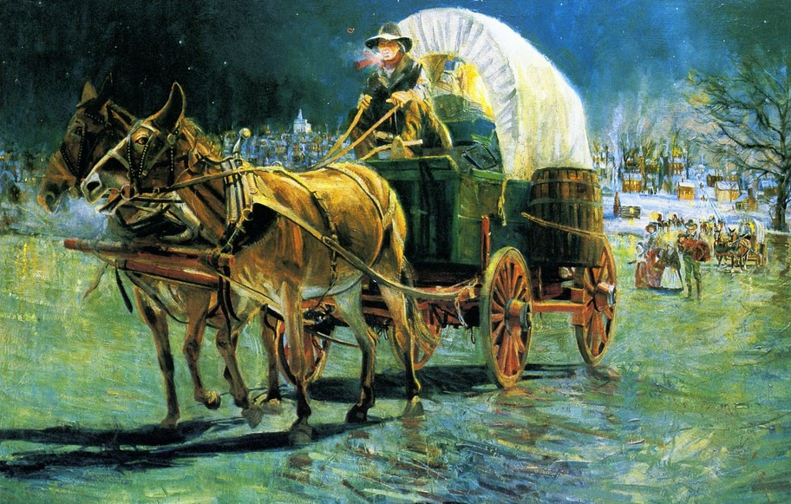
Joy and thankfulness filling their song

