You've had a birthday shout Hooray!
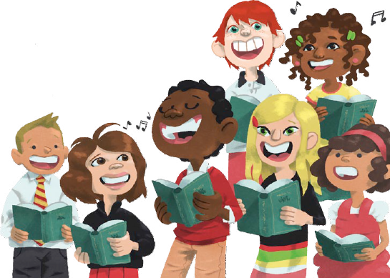
We want to sing to you today
One year older and wiser, too
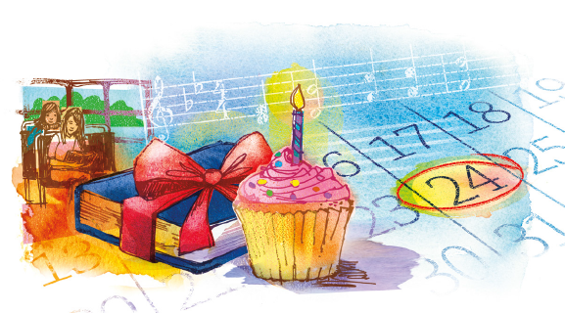
Happy birthday to you

